AERIS TRAVEL PLANNER · TEAM CABBAGE · CODENECTION PROTOTYPE
Aeris User Flows
Nine charts, one rule.
Every travel app can search and book. What Aeris does differently is that nothing books, pays, votes or reshuffles your itinerary without an explicit approval — and every one of those approvals is on the record. These nine flows are drawn so that the approval gate shows up as a shape you can point at, not a claim in a pitch.
Flows | Scenarios | Approval gates | Screens named | PRD items closed
9 charts | 6 + master + component + IA | 4 entry points, 1 component | 19 | 12 of 13
The spine

Three rules every flow obeys
These are not slogans. Each one shows up as a specific, repeated shape in the charts, which is what makes the flow set read as one system rather than nine unrelated diagrams.

Rule 01 — Two tracks, one destination
Manual browsing and Aeris suggestions start from the same screen and rejoin at the same candidate list. The AI is a fork in the path, never a toll gate. A traveller who ignores it entirely still reaches a booked trip.

Rule 02 — Exploring is free, committing is gated
Search, filter, compare and draft suggestions apply instantly. Anything that moves money, a schedule or a booking passes through one shared review-and-confirm step that shows old versus new before it writes anything.

Rule 03 — Solo is not a stripped group trip
At one member, voting, splitting and payer assignment do not appear greyed out — they are absent. The same code path serves both; the group machinery collapses to a no-op instead of nagging a solo traveller.
Notation

How to read these charts
One shape language across all nine diagrams.
Shape | Meaning
Rounded pill, green | Start or end — where a scenario opens and the state it leaves the trip in.
Slanted box, blue | User input — something the traveller types, picks or submits.
Plain rectangle, grey | System action — the application writes, calculates or displays.
Diamond | Decision. Every branch in these charts has a labelled exit.
Double-edged box, purple | Aeris engine — rule-based scoring, matching or ranking. Deterministic in MVP.
Hexagon, amber, heavy border | Approval gate. Nothing past this point happens without an explicit human press.
Red-bordered box | Error or alternative path — empty states, outages, rejections, conflicts.
Teal-bordered box | Central Trip Dashboard — the single source of truth every flow returns to.
Dashed grey box | Out of MVP. Deliberately deferred to v1 and labelled as such inside the chart.

FL-00 · Master flow — stranger to completed trip
The whole product on one page. Solo and group run as parallel lanes that rejoin at checkout, then everything converges on the Central Trip Dashboard, which the money loop and the disruption loop both feed back into.
Starts with | A visitor landing on Aeris for the first time
Ends with | Trip completed, balances settled, change history intact
Approval gates | 2 on the main line — booking and disruption
Covers | All four Ideas in a single pass

Branches worth pointing at
- Invite anyone? One question splits solo from group. Answering no hides voting, splitting and payer assignment entirely for the rest of the trip.
- Common window found? Has three exits, not two: full overlap, partial with the blocker named, and none. Group tools that only handle the happy case are why people go back to the chat thread.
- Both loops return to the dashboard. Expenses and disruptions are not dead ends; each writes back to the same board the traveller already reads.

What it earns in the rubric
- Mockup completeness (2%) — the rubric’s top band is "covers the core flow end-to-end." This is that, literally.
- Effectiveness (7%) — the before and after is visible: five browser tabs and a group chat collapse into one lane.
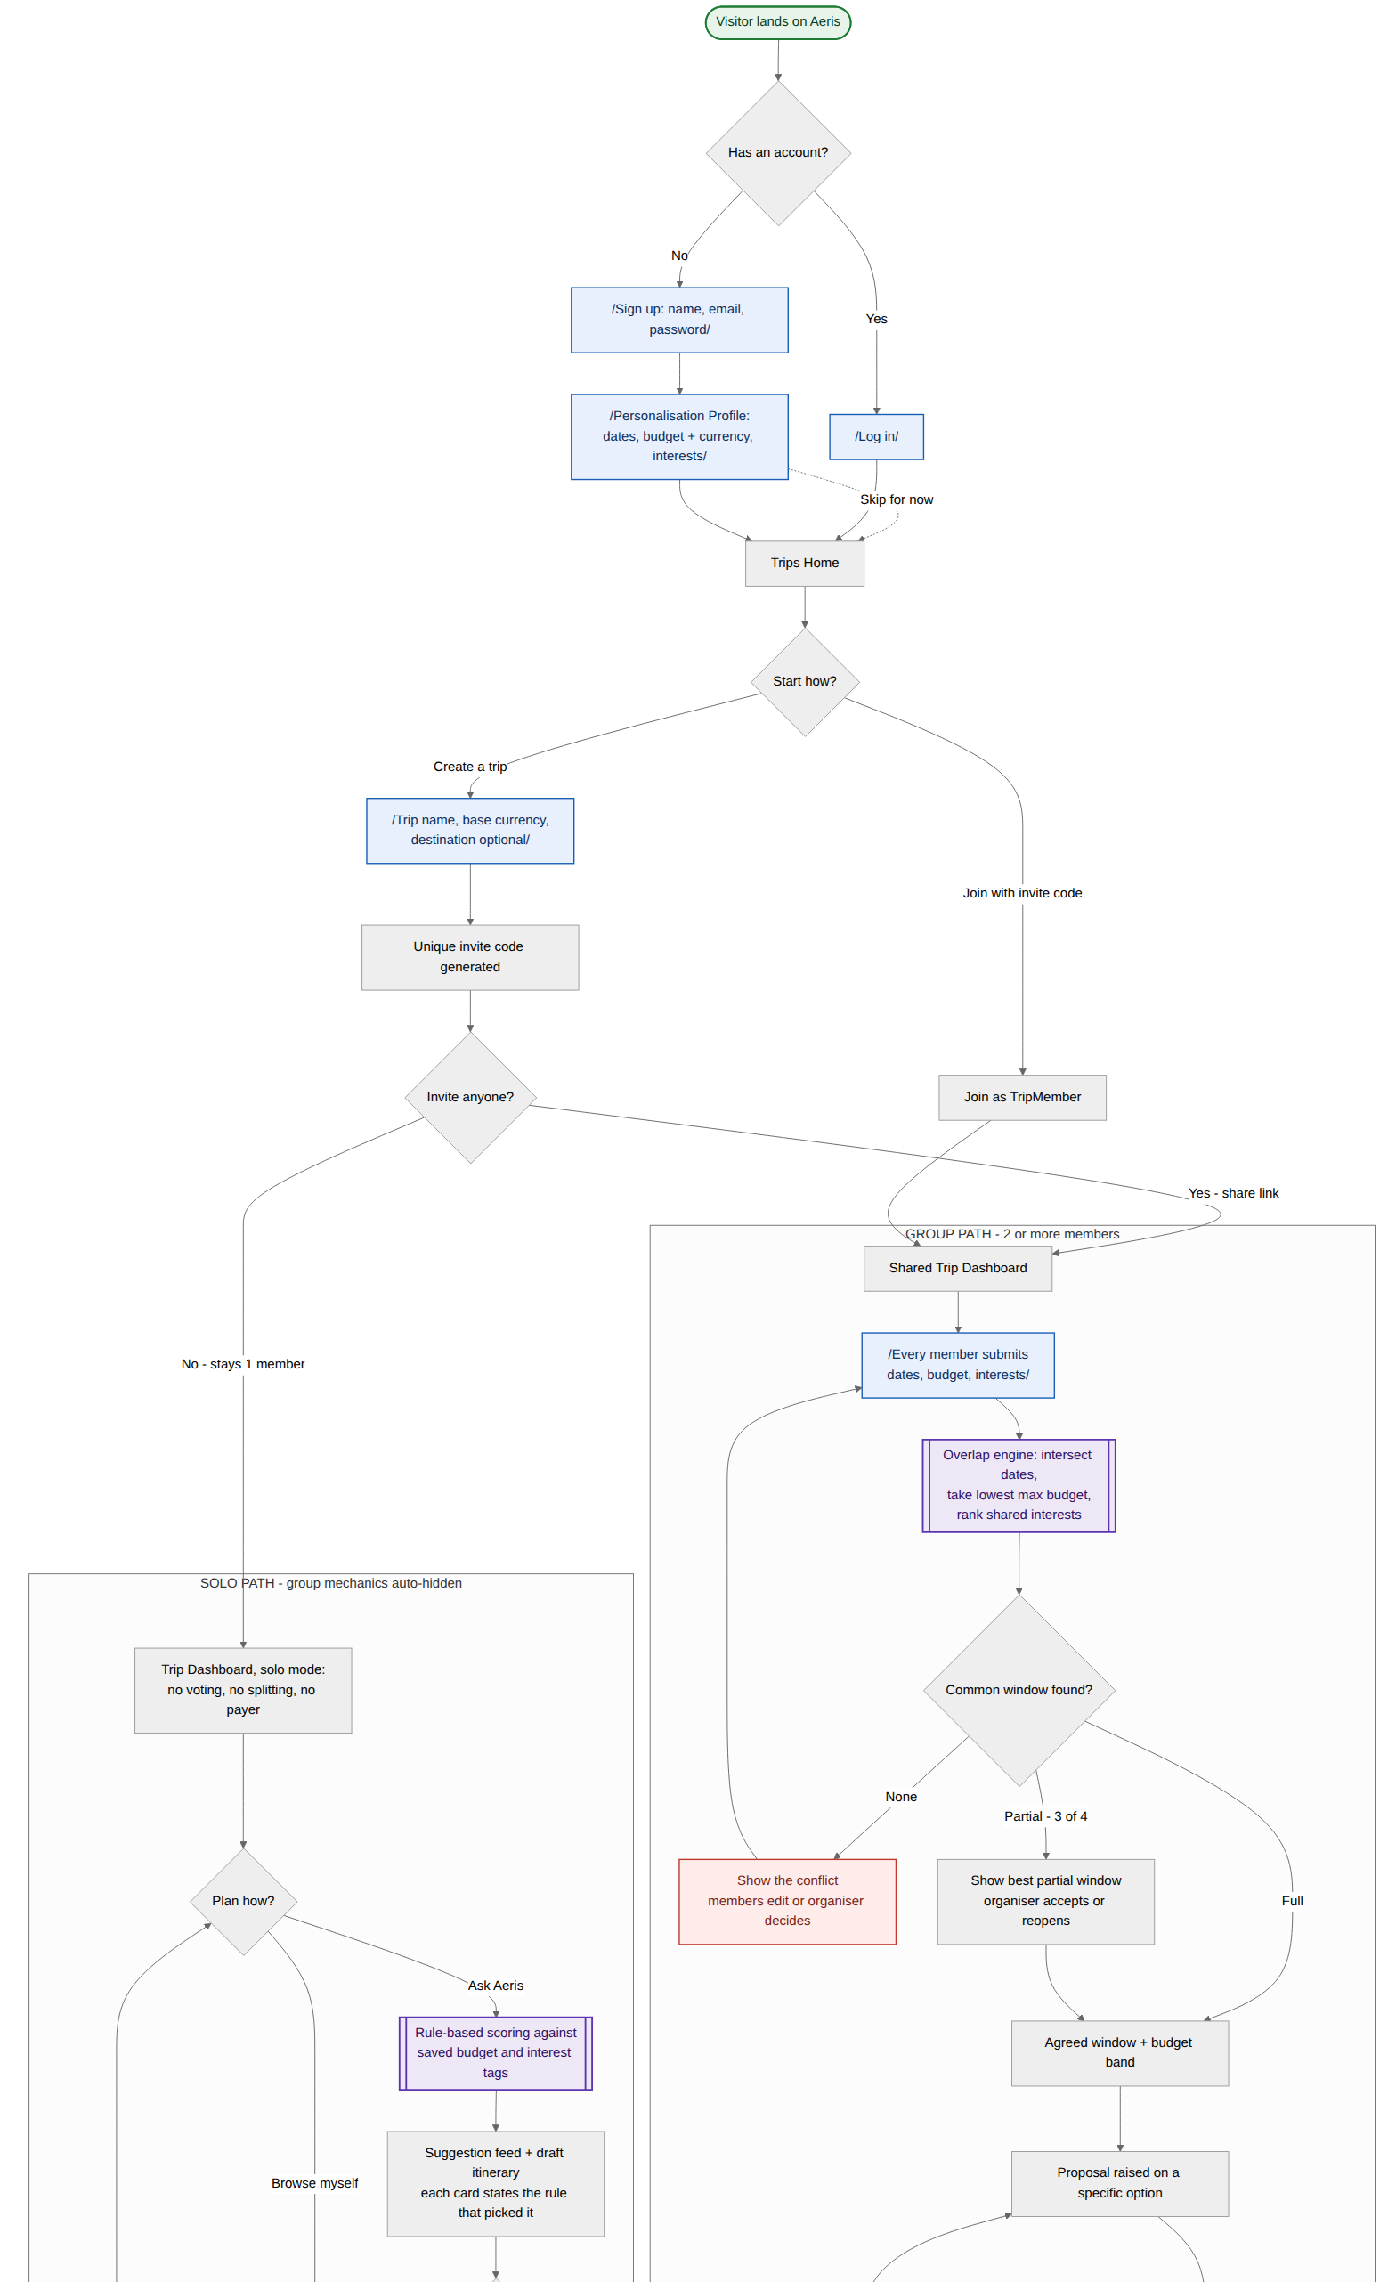
FL-00 — Master flow — stranger to completed trip — part 1 of 2
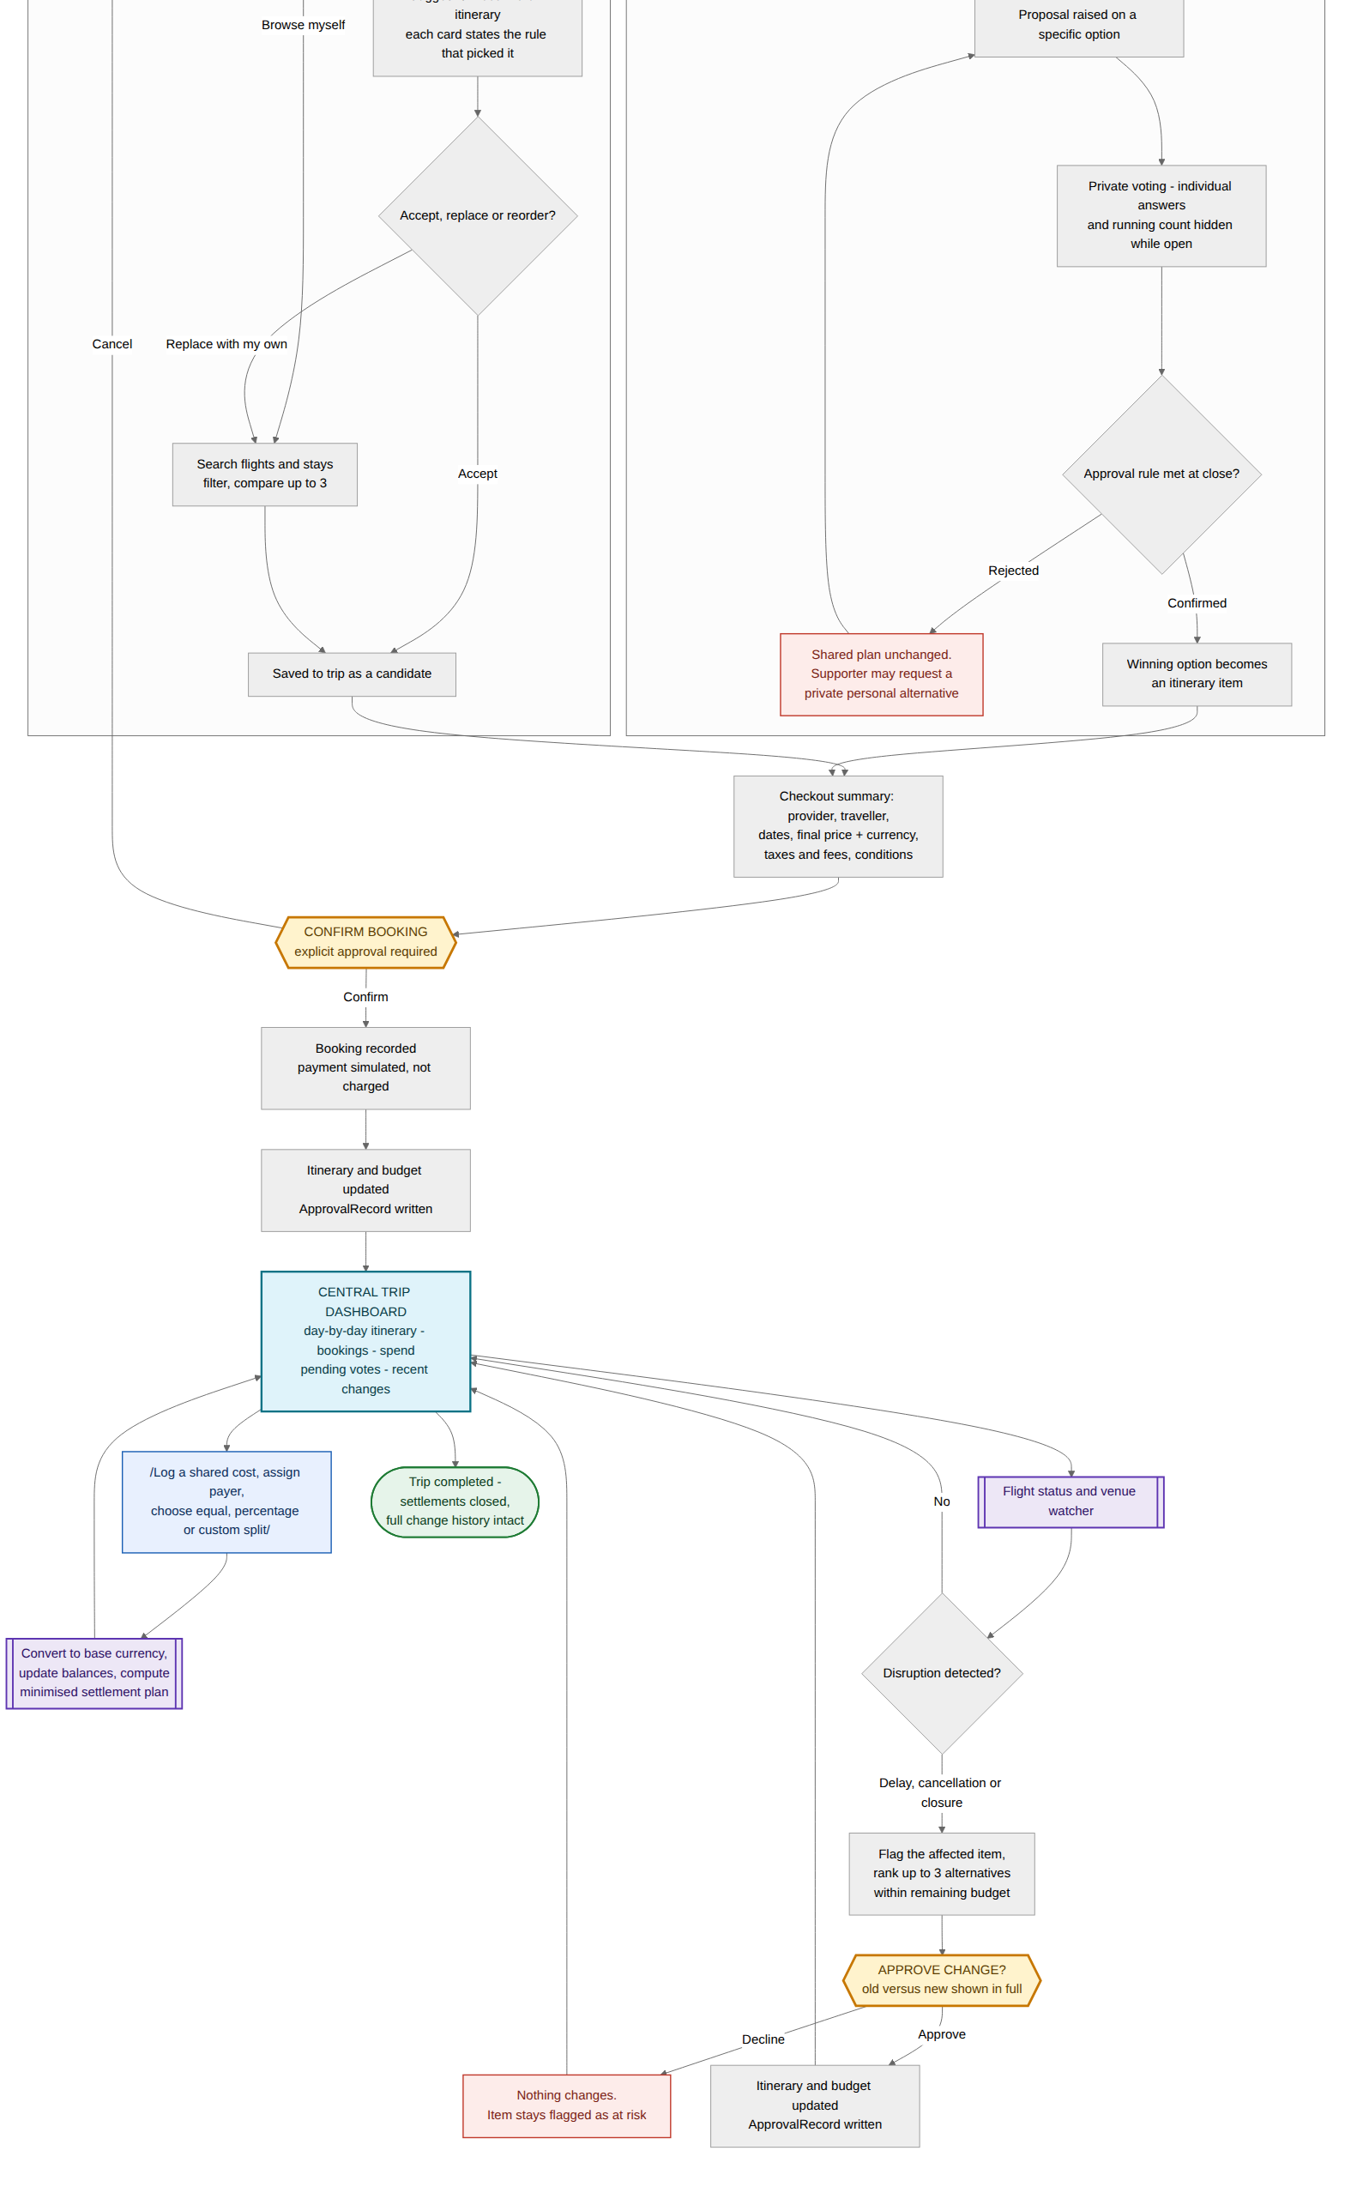
FL-00 — Master flow — stranger to completed trip — part 2 of 2

FL-01 · Registration, login and the personalisation profile
Getting a person into the product and capturing the three inputs — dates, budget, interests — that make every later recommendation specific rather than generic. The profile is skippable so the trip is never held hostage to a form.
Trigger | User opens Aeris
User enters | Name, email, password, home currency; then date ranges, max budget, interest tags
Ends with | Trips Home, ready to create or join a trip
Requirements | FR-AUTH-1 to 4, FR-PROFILE-1 to 3

Branches worth pointing at
- Skip is a real edge, not a dead link. A traveller who skips the profile still reaches Trips Home; Aeris simply has nothing to score against until they fill it in, and says so rather than guessing.
- Failed login errors are deliberately generic and the reset confirmation is identical whether or not the email exists — otherwise the form becomes a way to discover who has an account.
- The three profile fields are exactly the three the recommender reads. Travel pace, food requirements and accessibility are described in the ideas document but are out of MVP scope, so no UI implies they are being matched on.

What it earns in the rubric
- Usability and UX (4%) — every failure state has a labelled way back to a working screen.
- Scope realism (5%) — the flow visibly collects only what the build actually consumes.
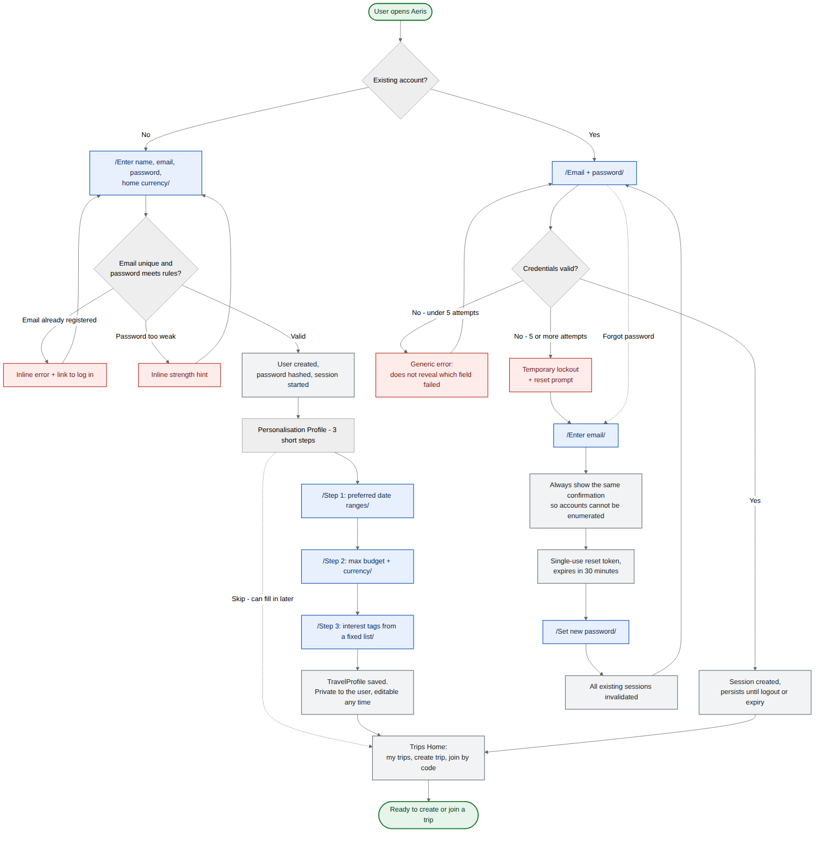
FL-01 — Registration, login and the personalisation profile

FL-02 · Solo traveller — search, compare, book
The flow that proves the product’s central claim. The manual track and the Aeris track sit side by side at the top of the same screen, produce candidates into the same list, and end at the same approval gate.
Trigger | Traveller opens a trip dashboard
User enters | Origin, destination, dates, travellers, filters; then an explicit Confirm
Ends with | A confirmed booking, an itinerary item, a budget line and a history entry
Requirements | FR-SEARCH-1 to 4, FR-REC-1 to 4, FR-BOOK-1 to 3, FR-APPROVE-1 to 3

Branches worth pointing at
- "Ignore — I will browse" is a first-class exit from the suggestion feed. Aina, the solo persona, specifically does not want to be locked into what the system recommends.
- Two distinct empty states. A provider outage and a genuine zero-result search are different problems and get different screens. Stale or fabricated results are never shown in place of live data.
- Every suggestion card states the rule that produced it — "matches culture, under your budget" — templated from the actual scoring inputs. That keeps the MVP honest about being rule-based instead of dressing it up as a model.
- Confirm Booking is the only door. Cancelling returns to the comparison view with nothing written.

What it earns in the rubric
- Originality (7%) — the dual-track fork is the visual argument that Aeris is not another recommend-then-book black box.
- Understanding the problem (5%) — outage and zero-result branches show you thought past the demo path.
- Technical viability (6%) — the chart shows exactly where a live provider API is called and what happens when it is not there.
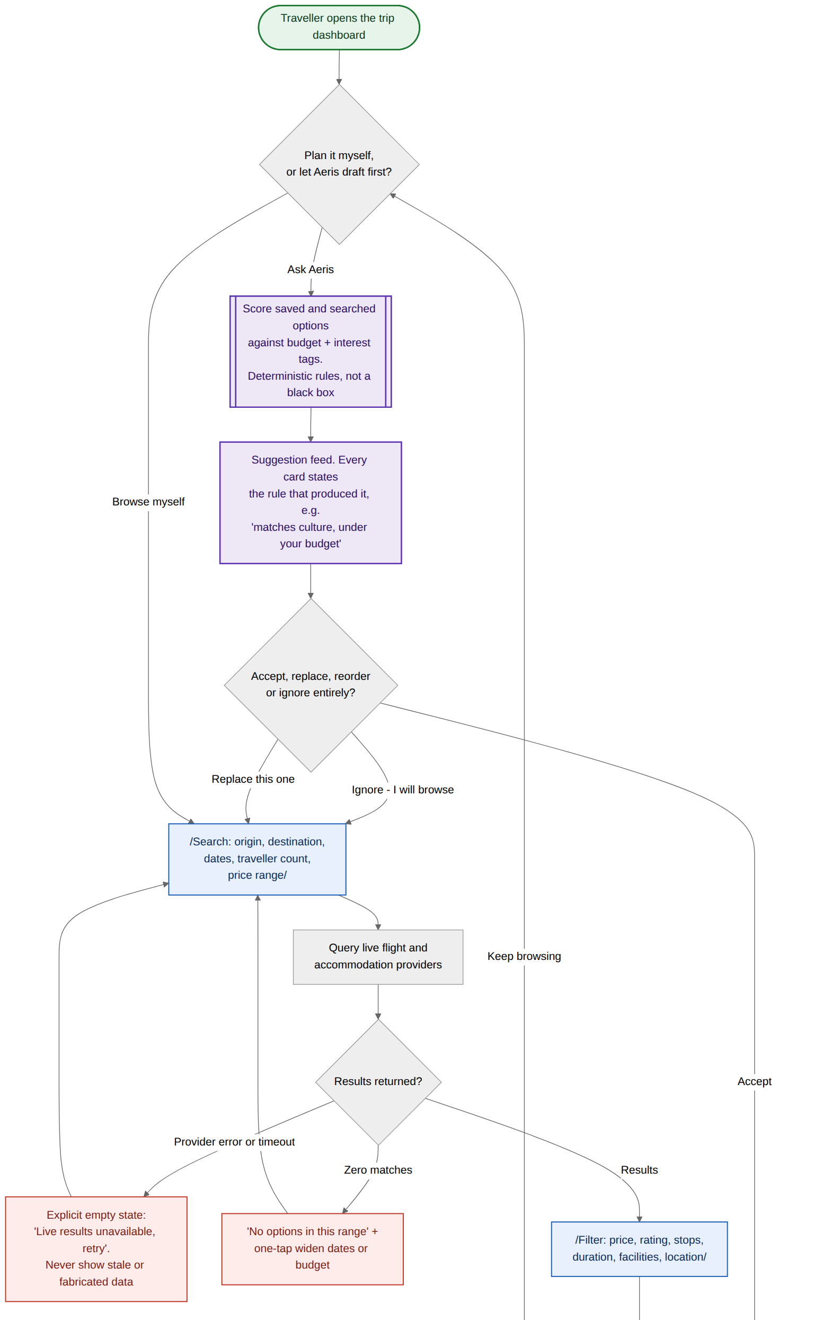
FL-02 — Solo traveller — search, compare, book — part 1 of 2
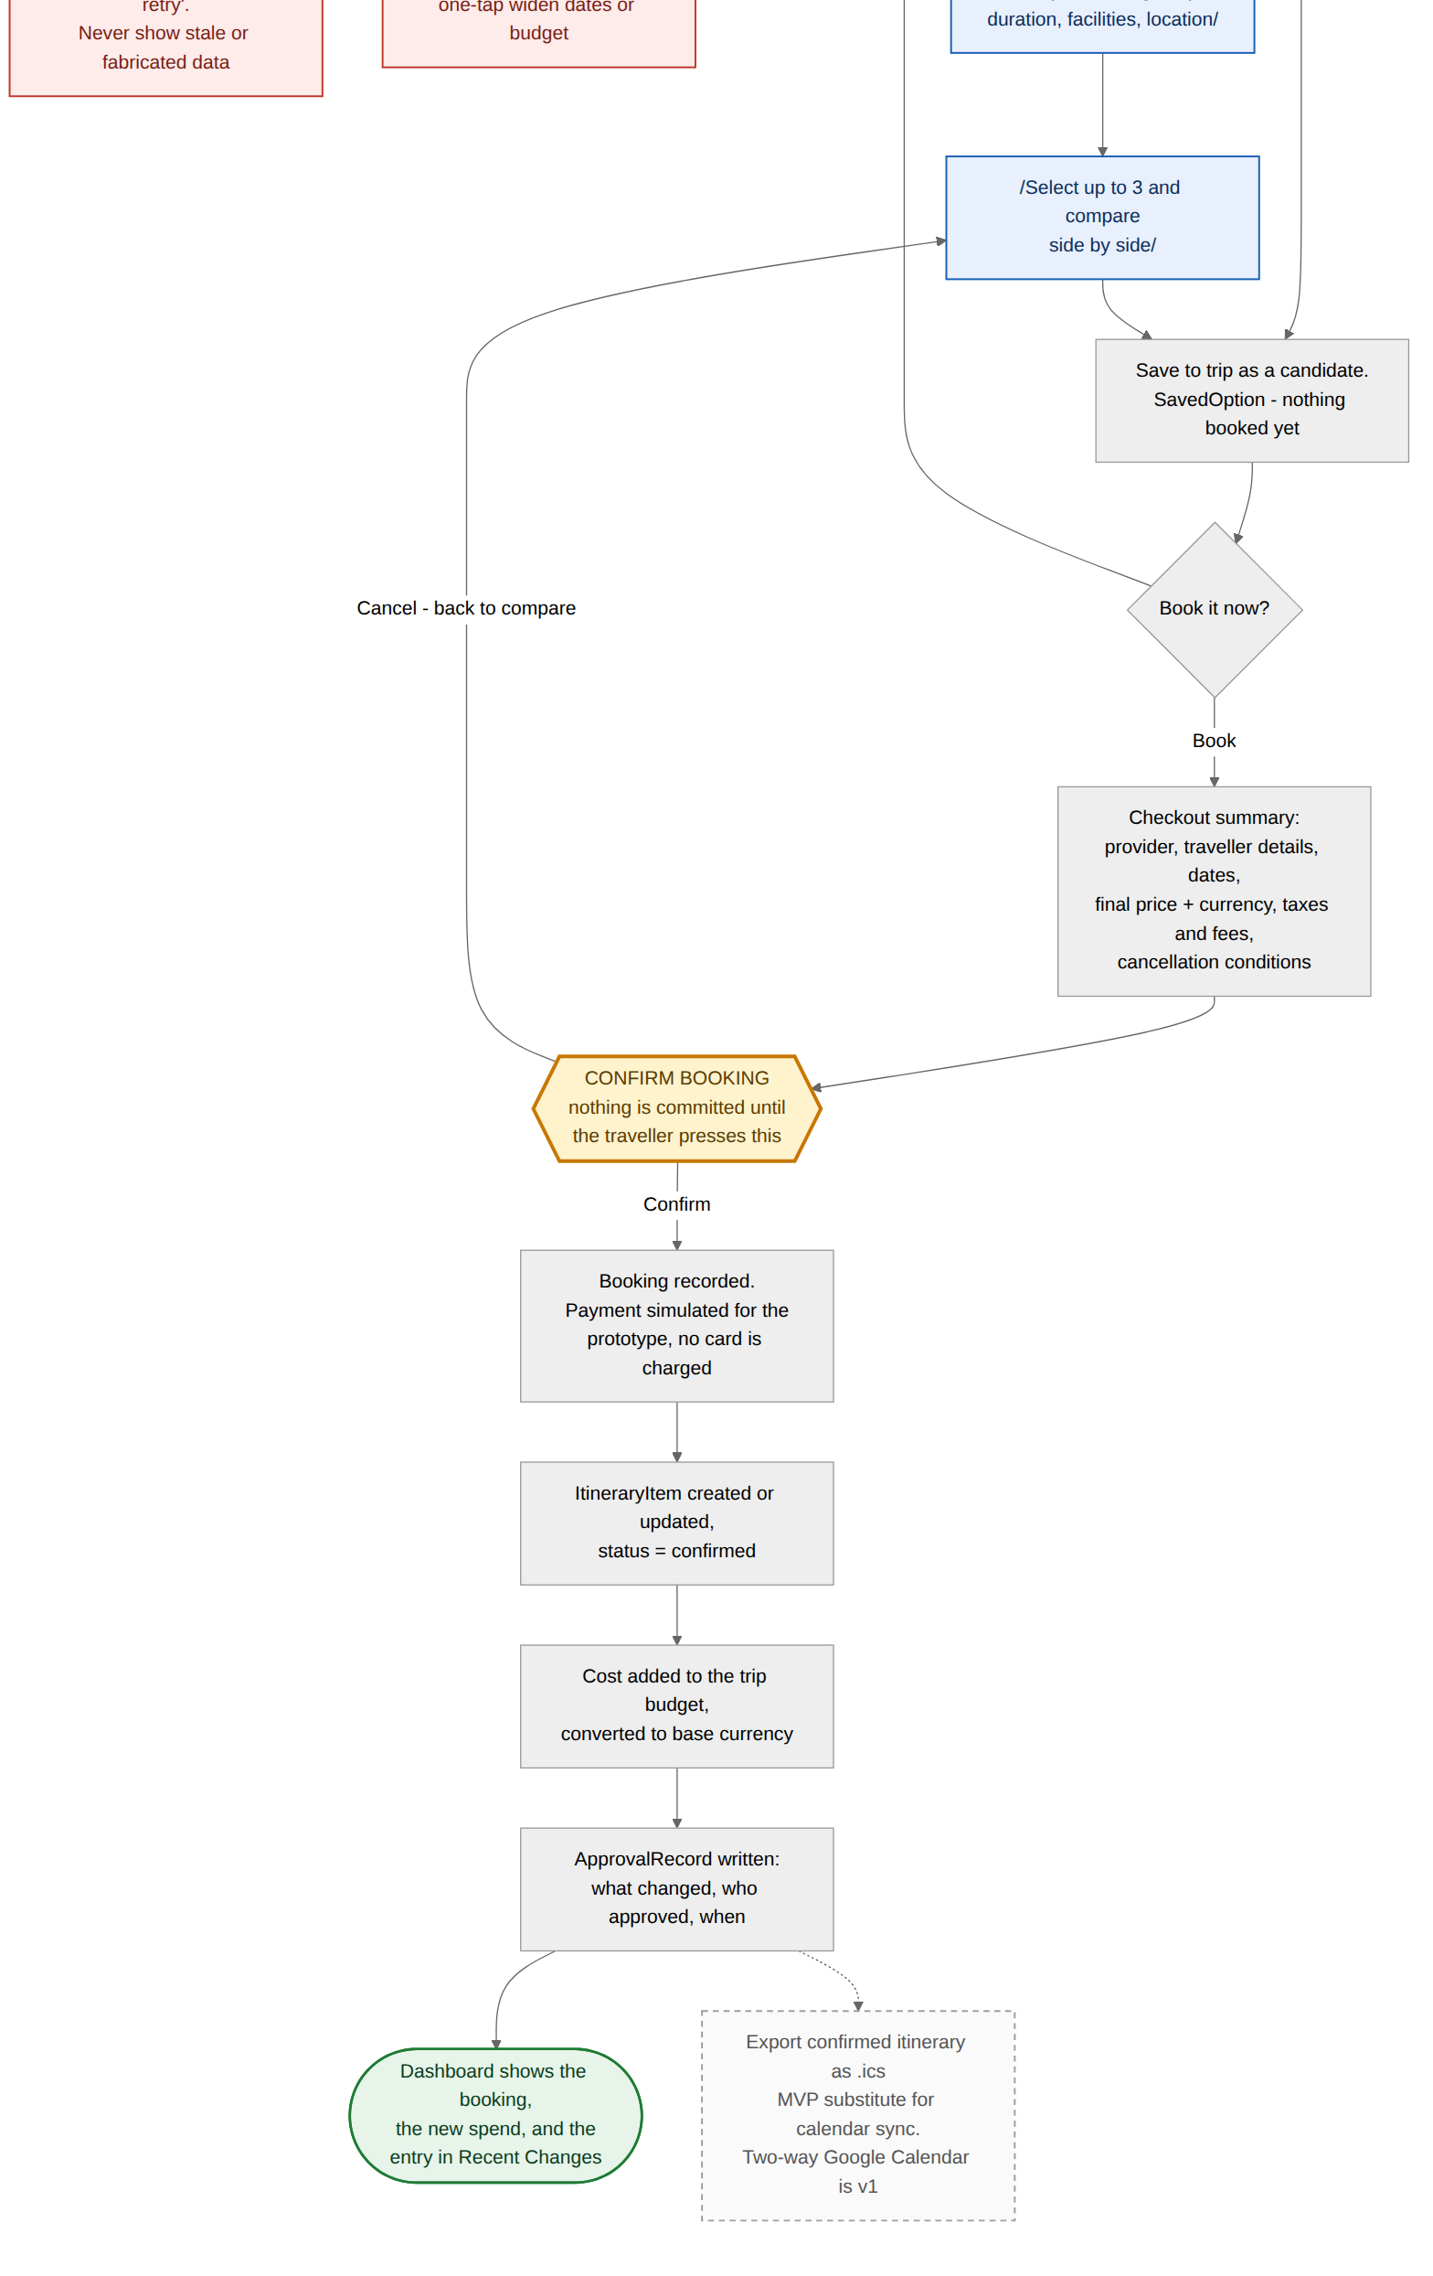
FL-02 — Solo traveller — search, compare, book — part 2 of 2

FL-03 · Group organiser — create, invite, match preferences
This is the flow that replaces the group chat poll. Preferences are submitted privately, the system computes the overlap, and the dashboard reports progress as a count so the organiser stops chasing people one by one.
Trigger | Organiser creates a trip and shares an invite code
User enters | Trip name and base currency; each member: dates, max budget, interests
Ends with | An agreed window and budget band, and a proposal ready to vote on
Requirements | FR-TRIP-1 to 5, FR-MATCH-1 to 2

Branches worth pointing at
- "3 of 4 members submitted" is the whole coordination fix. The organiser sees status without seeing anyone’s private budget — the thing that makes people answer honestly.
- No overlap is a designed outcome, not an error. The chart shows the clash plainly, names who blocks which dates, and offers two exits: members edit, or the organiser sets the window.
- Partial overlap names who misses out rather than silently picking dates for three of four people.
- Late joiners get read-only on already-confirmed items but can still vote on anything open — the edge case the PRD flagged as undefined, resolved here.
- Editing a submission recomputes the overlap without disturbing votes already cast on an open proposal.

What it earns in the rubric
- Target group alignment (5%) — Wei Jian’s coordination tax is the specific pain this chart removes, step by step.
- Effectiveness (7%) — the before is a chat thread half the group ignores; the after is a counter and a computed window.
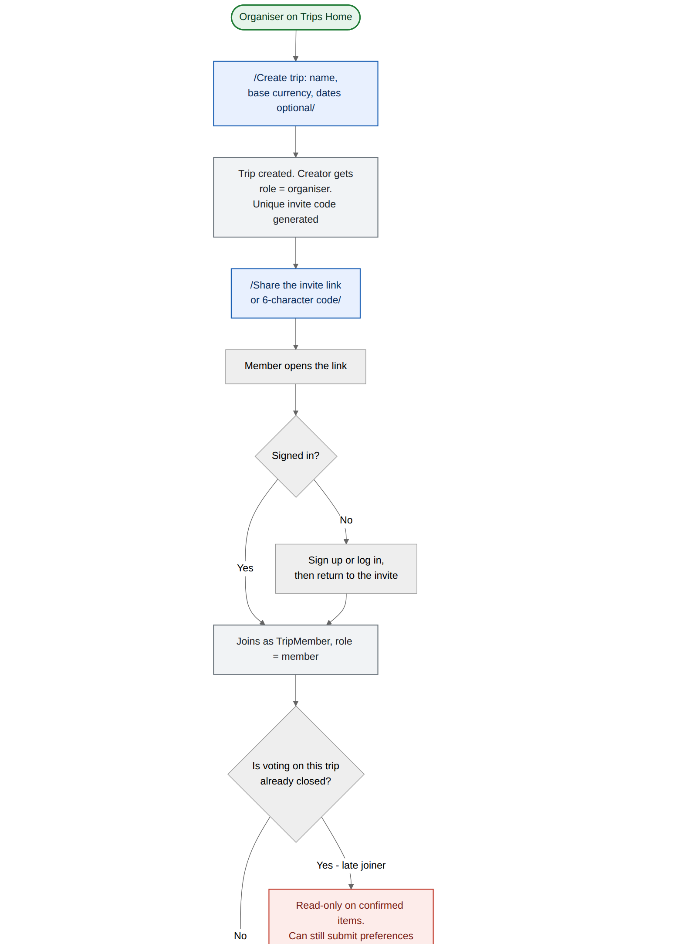
FL-03 — Group organiser — create, invite, match preferences — part 1 of 3
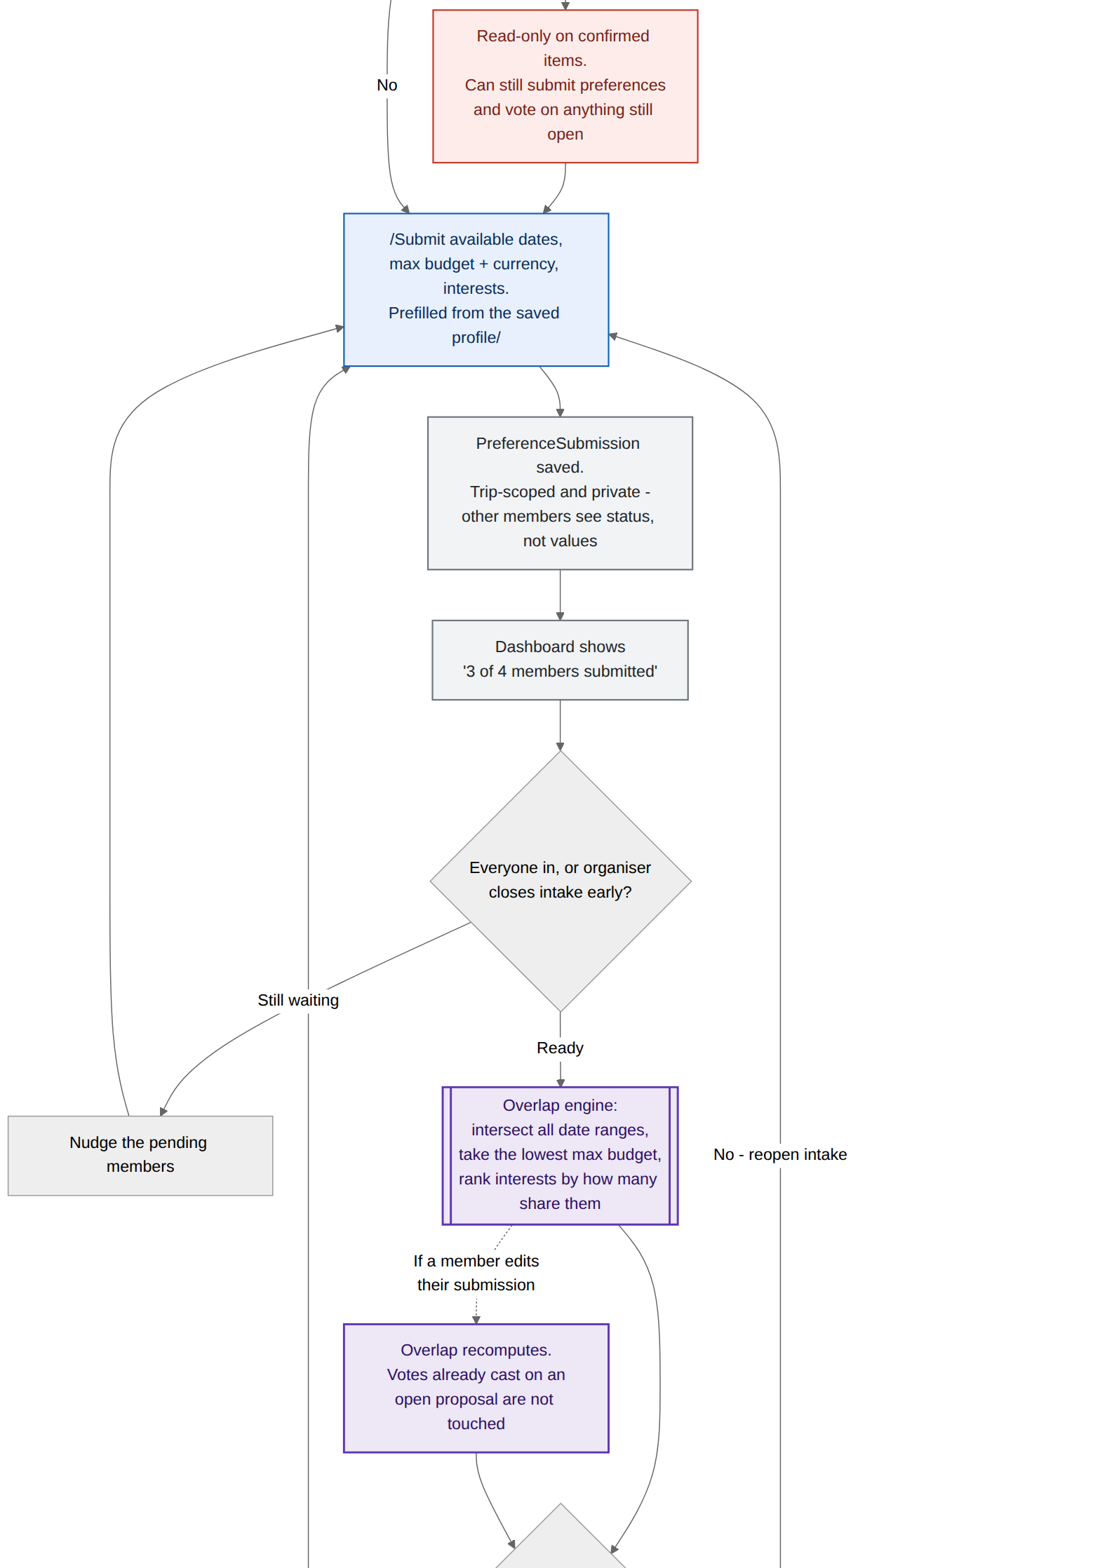
FL-03 — Group organiser — create, invite, match preferences — part 2 of 3
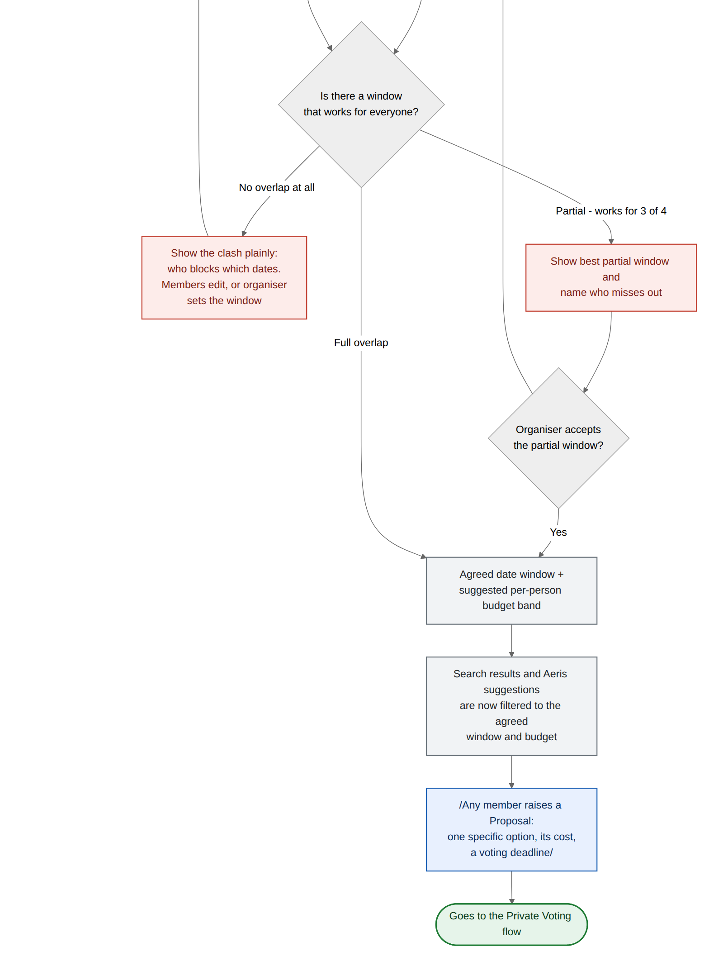
FL-03 — Group organiser — create, invite, match preferences — part 3 of 3

FL-04 · Private voting and the decision outcome
The privacy boundary is the feature. Individual answers and the running count stay hidden from everyone — the organiser included — until the proposal closes, and the tally is revealed to all members at the same moment.
Trigger | Any member raises a proposal with a cost and a deadline
User enters | One private vote per member, changeable until the deadline
Ends with | Itinerary updated, or plan unchanged plus a private alternative
Requirements | FR-VOTE-1 to 5, FR-APPROVE-1 to 3

Branches worth pointing at
- A vote decides; an approval commits. These are two separate steps on purpose. Reaching the threshold sets the proposal to confirmed, but applying it to the itinerary still passes the approval gate with old versus new shown.
- Rejection has a dignified exit. The member who wanted the rejected option can ask Aeris privately for a personal alternative that is never posted to the group. That is a social design decision, not a technical one.
- Two undefined behaviours from the PRD are resolved here: ties go to an organiser deciding vote that is recorded as a tie-break, and a deadline reached with zero votes auto-extends once before falling to the organiser. Neither stalls silently.

What it earns in the rubric
- Novel features (5%) — hidden-until-close voting inside a travel planner is the standout twist. Most group tools show a live tally, which is exactly what makes people vote with the room.
- Differentiation (3%) — easy to state in one sentence against any existing option.
- Iteration (7%) — the resolved tie and zero-vote rules are documented evidence of the concept being refined, not just restated.
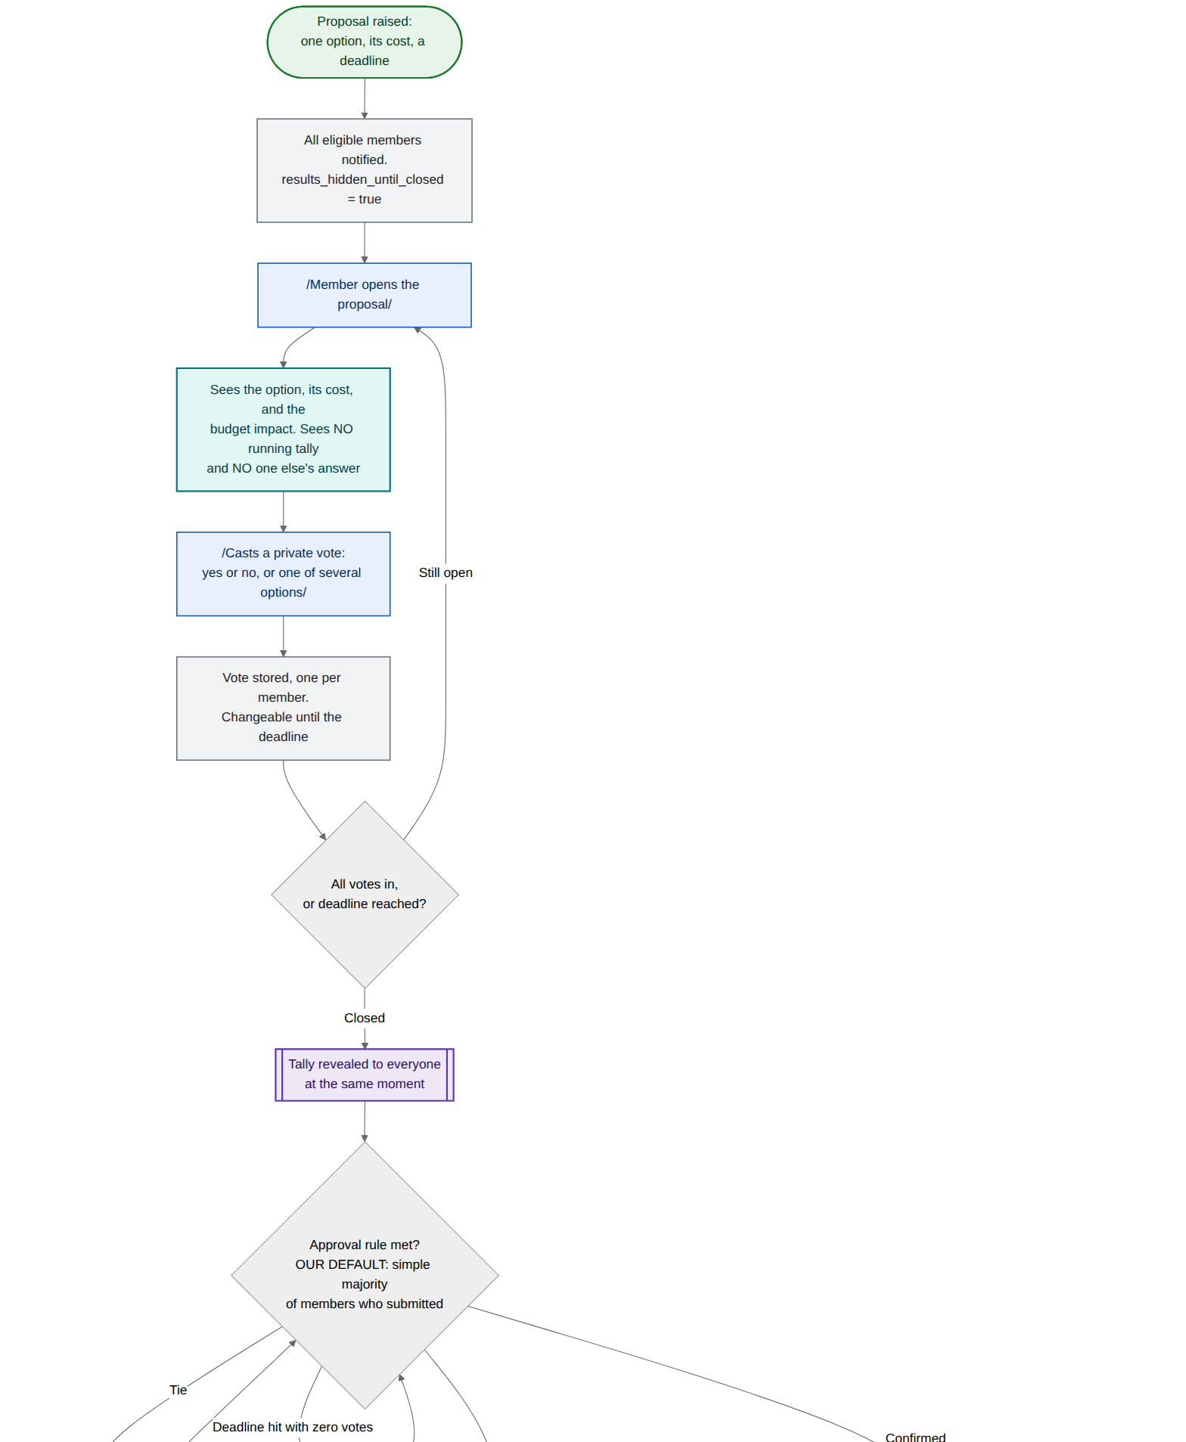
FL-04 — Private voting and the decision outcome — part 1 of 2
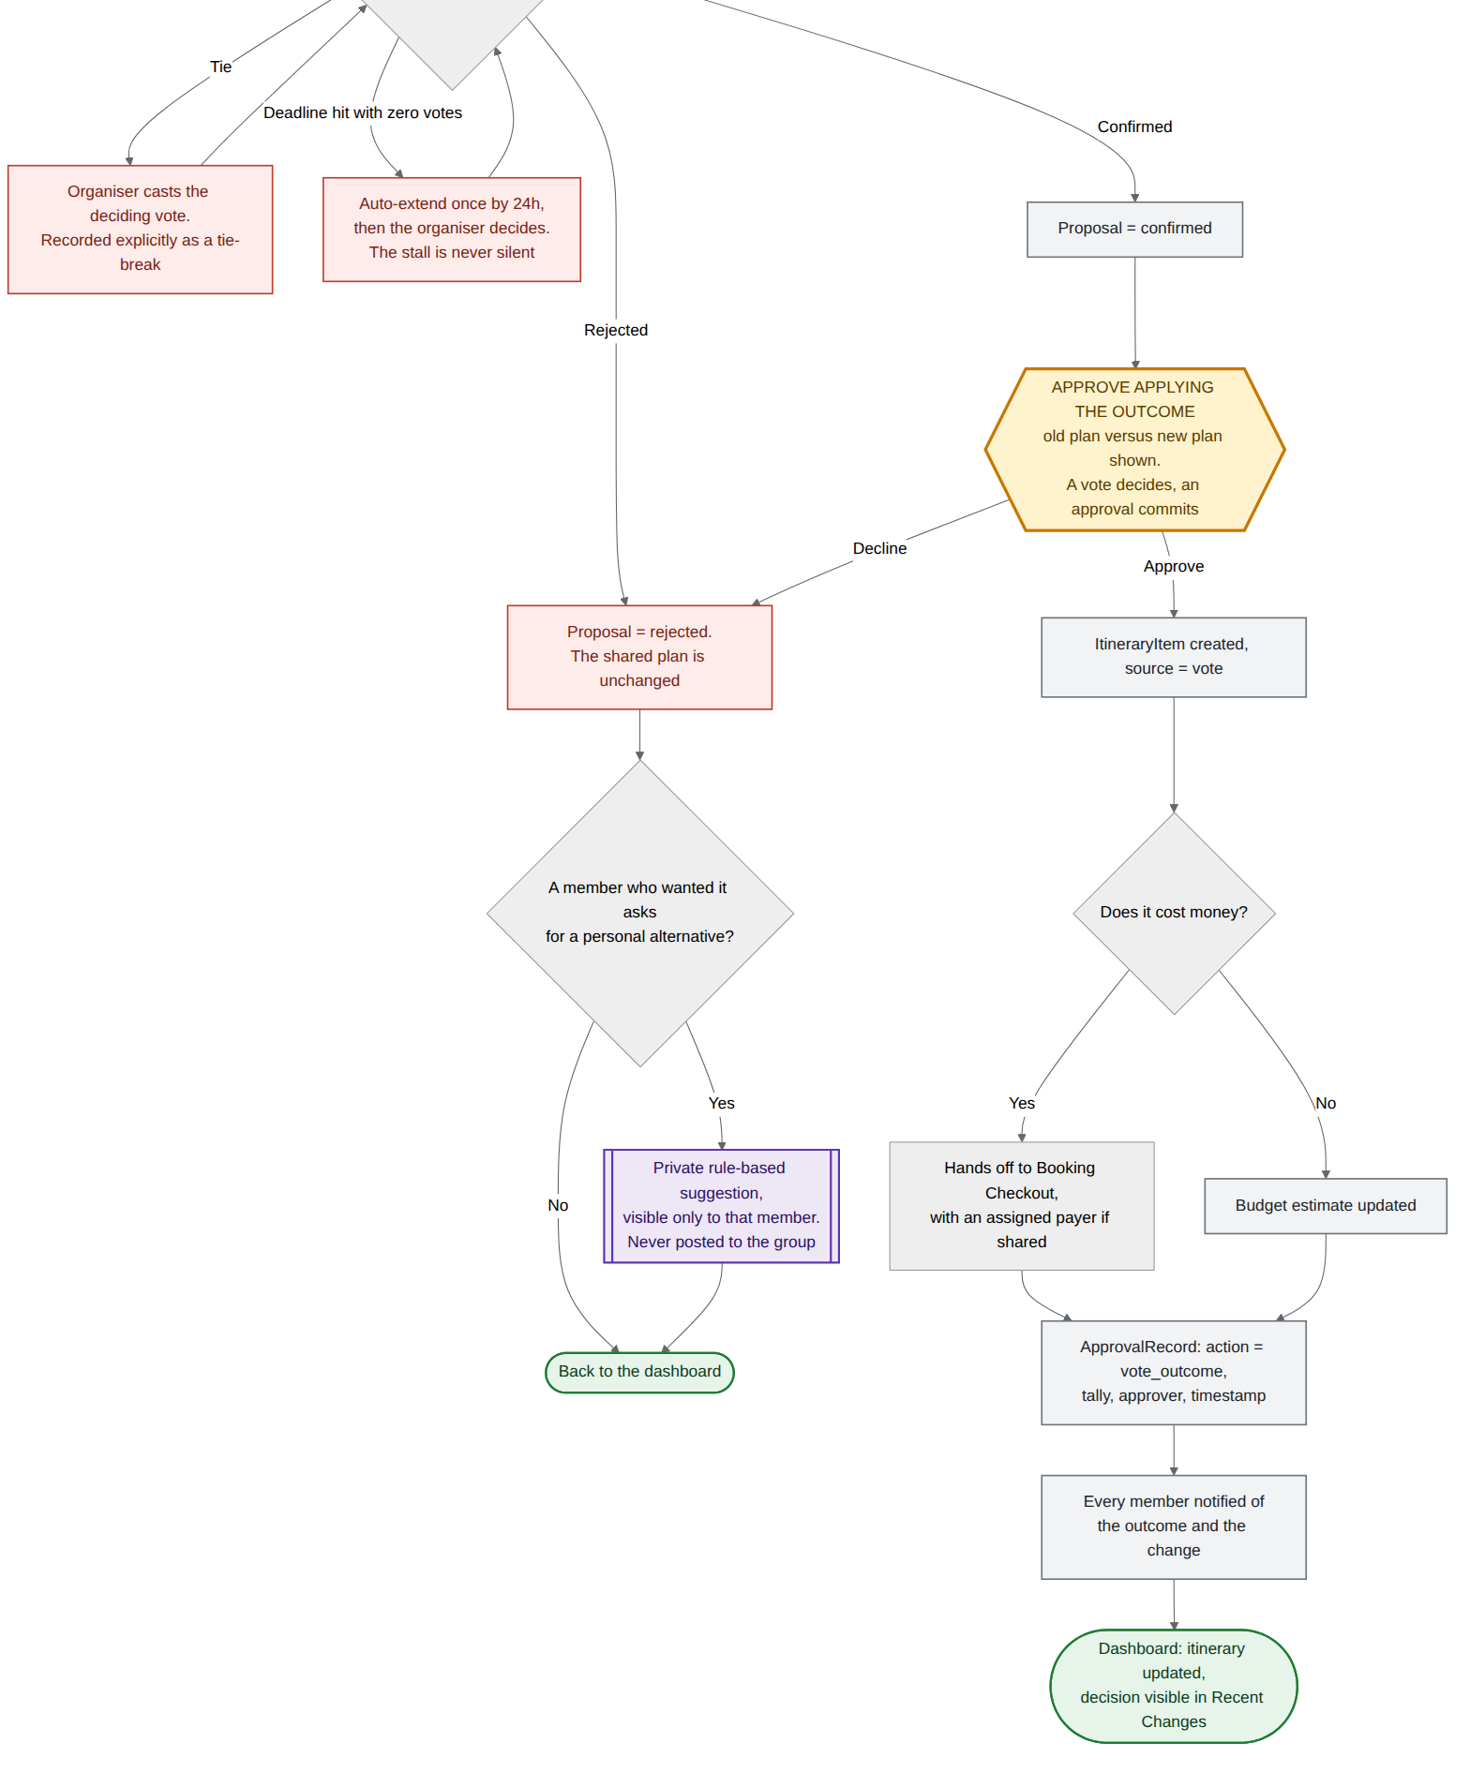
FL-04 — Private voting and the decision outcome — part 2 of 2

FL-05 · Multi-currency spend, assigned payer and settlement
Two entry points — a cost booked inside Aeris with an assigned payer, and a cost paid out in the world and logged afterwards — converge into the same expense record, the same split validation and the same settlement engine.
Trigger | Any shared cost, booked or logged
User enters | Amount, currency, category, payer, participants, split method
Ends with | Balances clear via the fewest possible transfers
Requirements | FR-BUDGET-1 to 6

Branches worth pointing at
- The rate service going down never blocks an entry. Aeris falls back to the last cached rate and stamps it — "rate as of 09:14" — so the number on screen is always something the traveller can reason about.
- Both amounts are stored. The original 8,000 JPY and the converted RM figure live side by side, so a conversion is never the only record of what was actually paid.
- Splits must reconcile before they are written. "RM12.50 still unallocated" blocks; it does not warn and proceed.
- Settlements need two sides. The payer marking it paid is not enough — the counterparty confirms receipt. Nobody can quietly close a debt.
- Remaining budget feeds back into search filters, recommendations and disruption alternatives. Budget is an input, not just a report.

What it earns in the rubric
- Effectiveness (7%) — the unpaid spreadsheet work Wei Jian does by hand disappears, and the chart shows exactly where.
- Technical viability (6%) — the minimised-settlement step is a real algorithm with a named fallback, not a hand-wave.
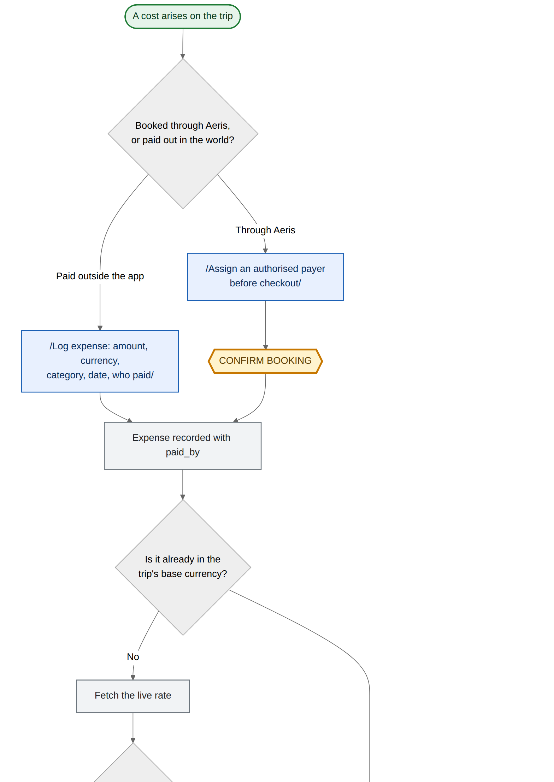
FL-05 — Multi-currency spend, assigned payer and settlement — part 1 of 3
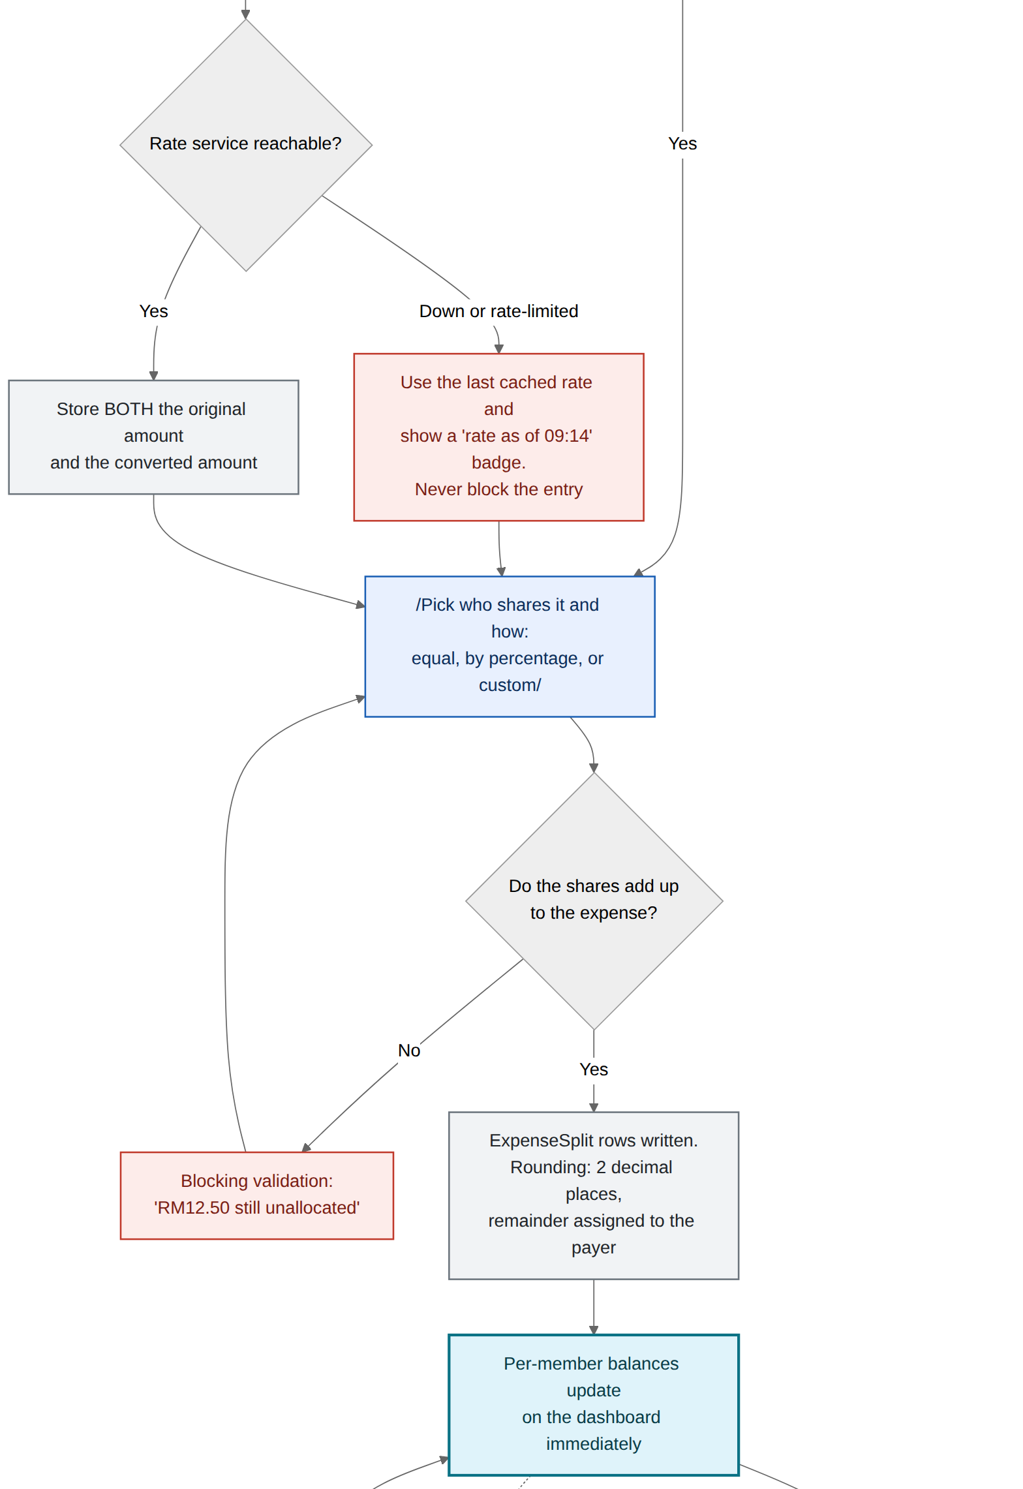
FL-05 — Multi-currency spend, assigned payer and settlement — part 2 of 3
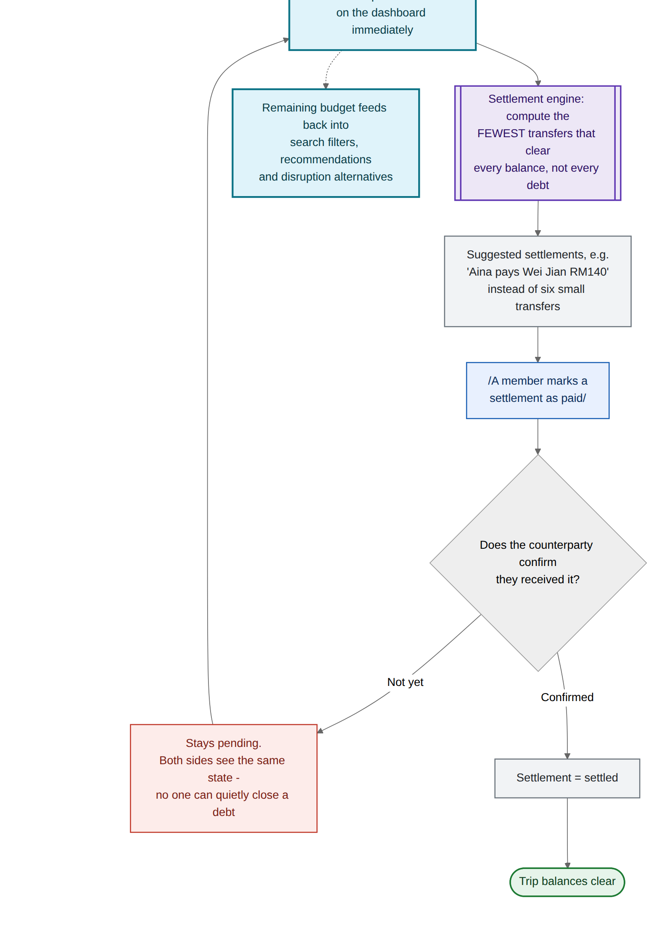
FL-05 — Multi-currency spend, assigned payer and settlement — part 3 of 3

FL-06 · Disruption detection, ranked alternatives, approved replan
A delay or cancellation is detected, debounced, ranked against the remaining budget, and presented as an explicit old-versus-new comparison. Declining is a supported outcome that leaves the item flagged rather than pretending it is fine.
Trigger | Flight status or venue change on a confirmed itinerary item
User enters | A choice among up to 3 alternatives, then an explicit approval
Ends with | Itinerary and budget updated, with the reason on the record
Requirements | FR-DISRUPT-1 to 5, FR-APPROVE-1 to 3

Branches worth pointing at
- An unknown is not a reassurance. When no live data exists for a route or venue, the item reads "status unavailable" — never a false "on time." That single branch is the difference between a trustworthy alert and a dangerous one.
- A 15-minute debounce stops a delay that resolves itself from generating an alert. Alert fatigue is how a travel app gets muted.
- No viable alternative is drawn. If nothing fits the remaining budget, Aeris says so and opens manual search on the same screen instead of showing a padded list.
- Declining keeps the flag. The item stays visibly at risk, so a decision to wait does not quietly become a forgotten problem.
- One item at a time. The cascading multi-item replan is drawn as a dashed v1 node — a deliberate, visible scope cut rather than an omission.

What it earns in the rubric
- Understanding the problem (5%) — debounce, unknown-status and no-alternative are the three things that break real disruption tools.
- Scope realism (5%) — the v1 boundary is on the chart, in dashed lines, where a judge can see it.
- Reach and scalability (3%) — the same watcher pattern extends to hotels, venues and weather without redrawing the flow.
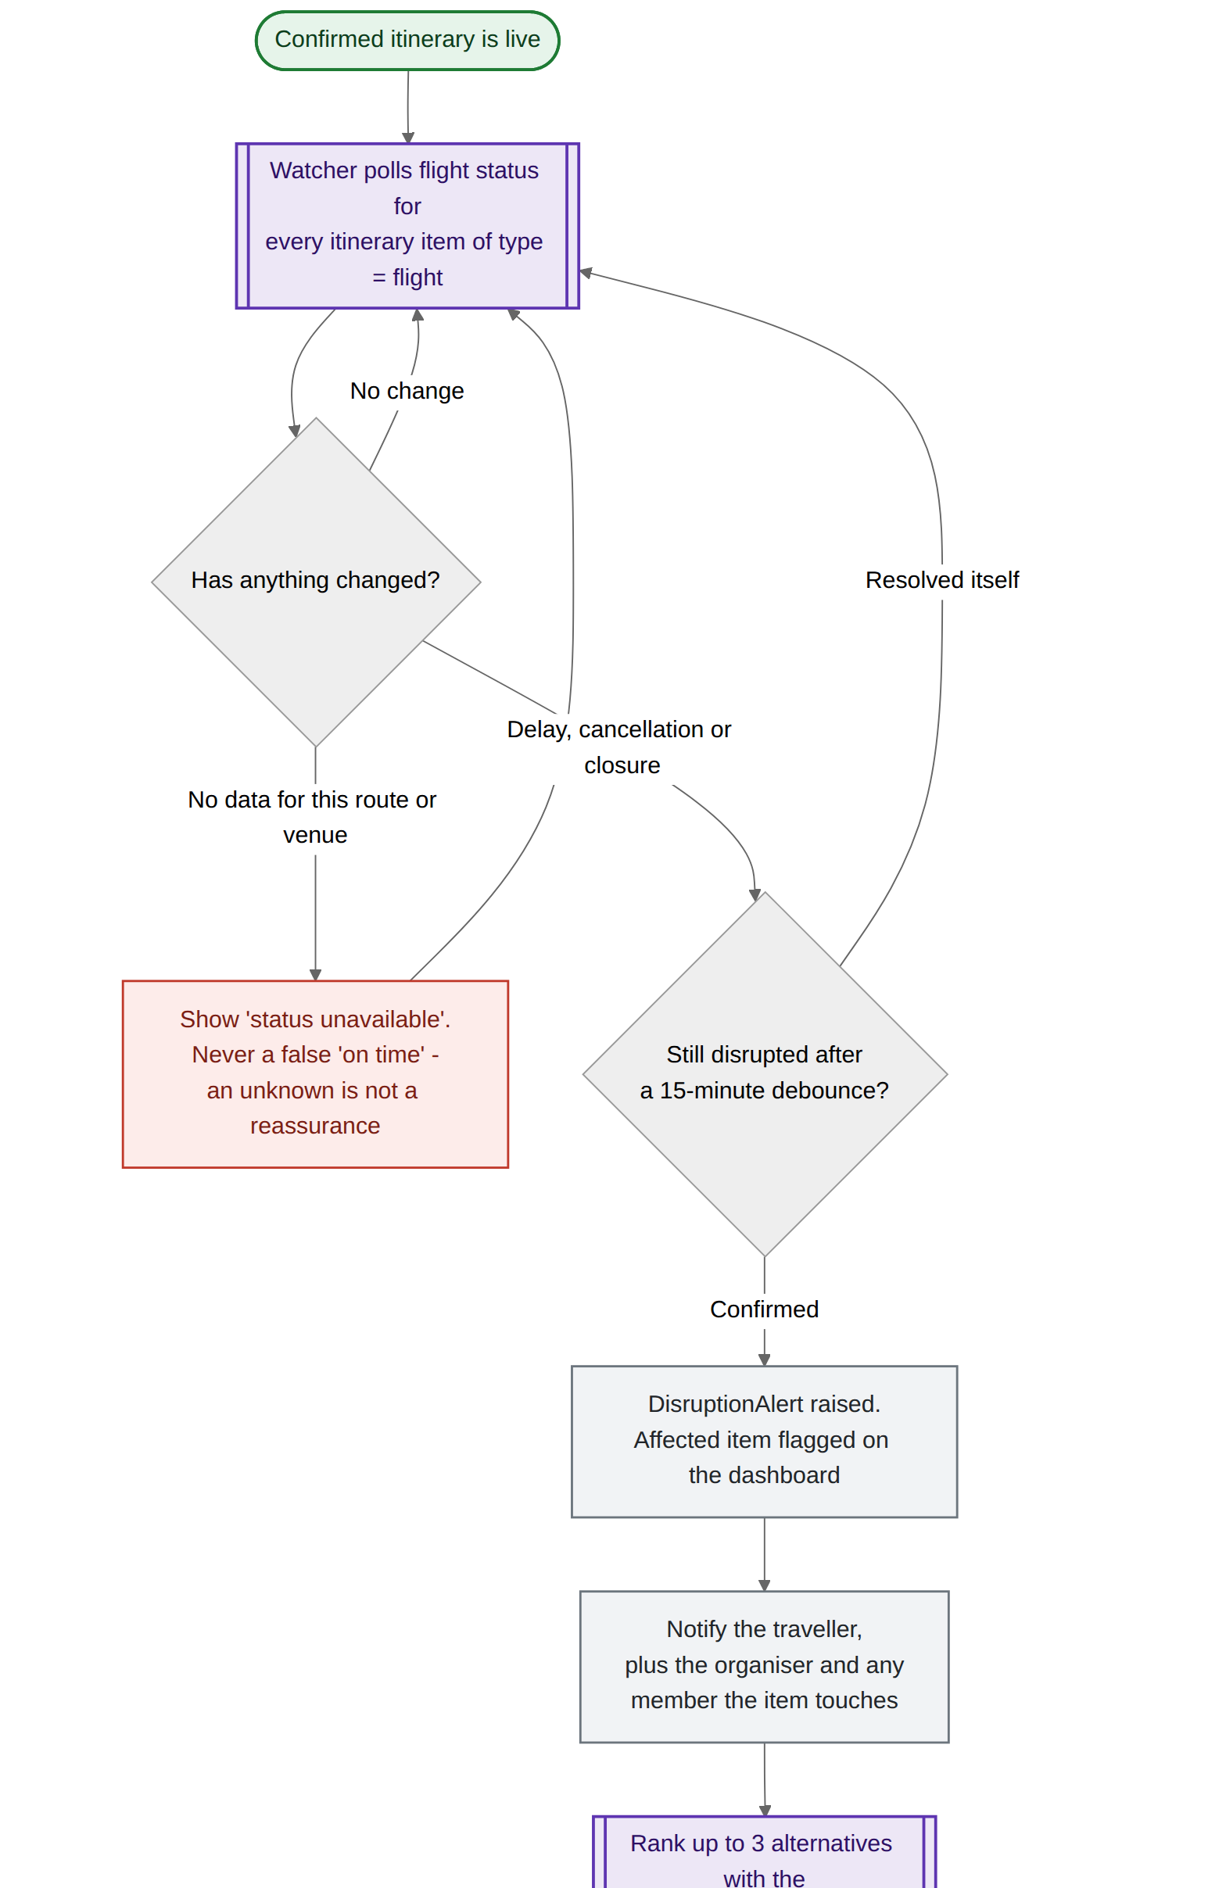
FL-06 — Disruption detection, ranked alternatives, approved replan — part 1 of 3
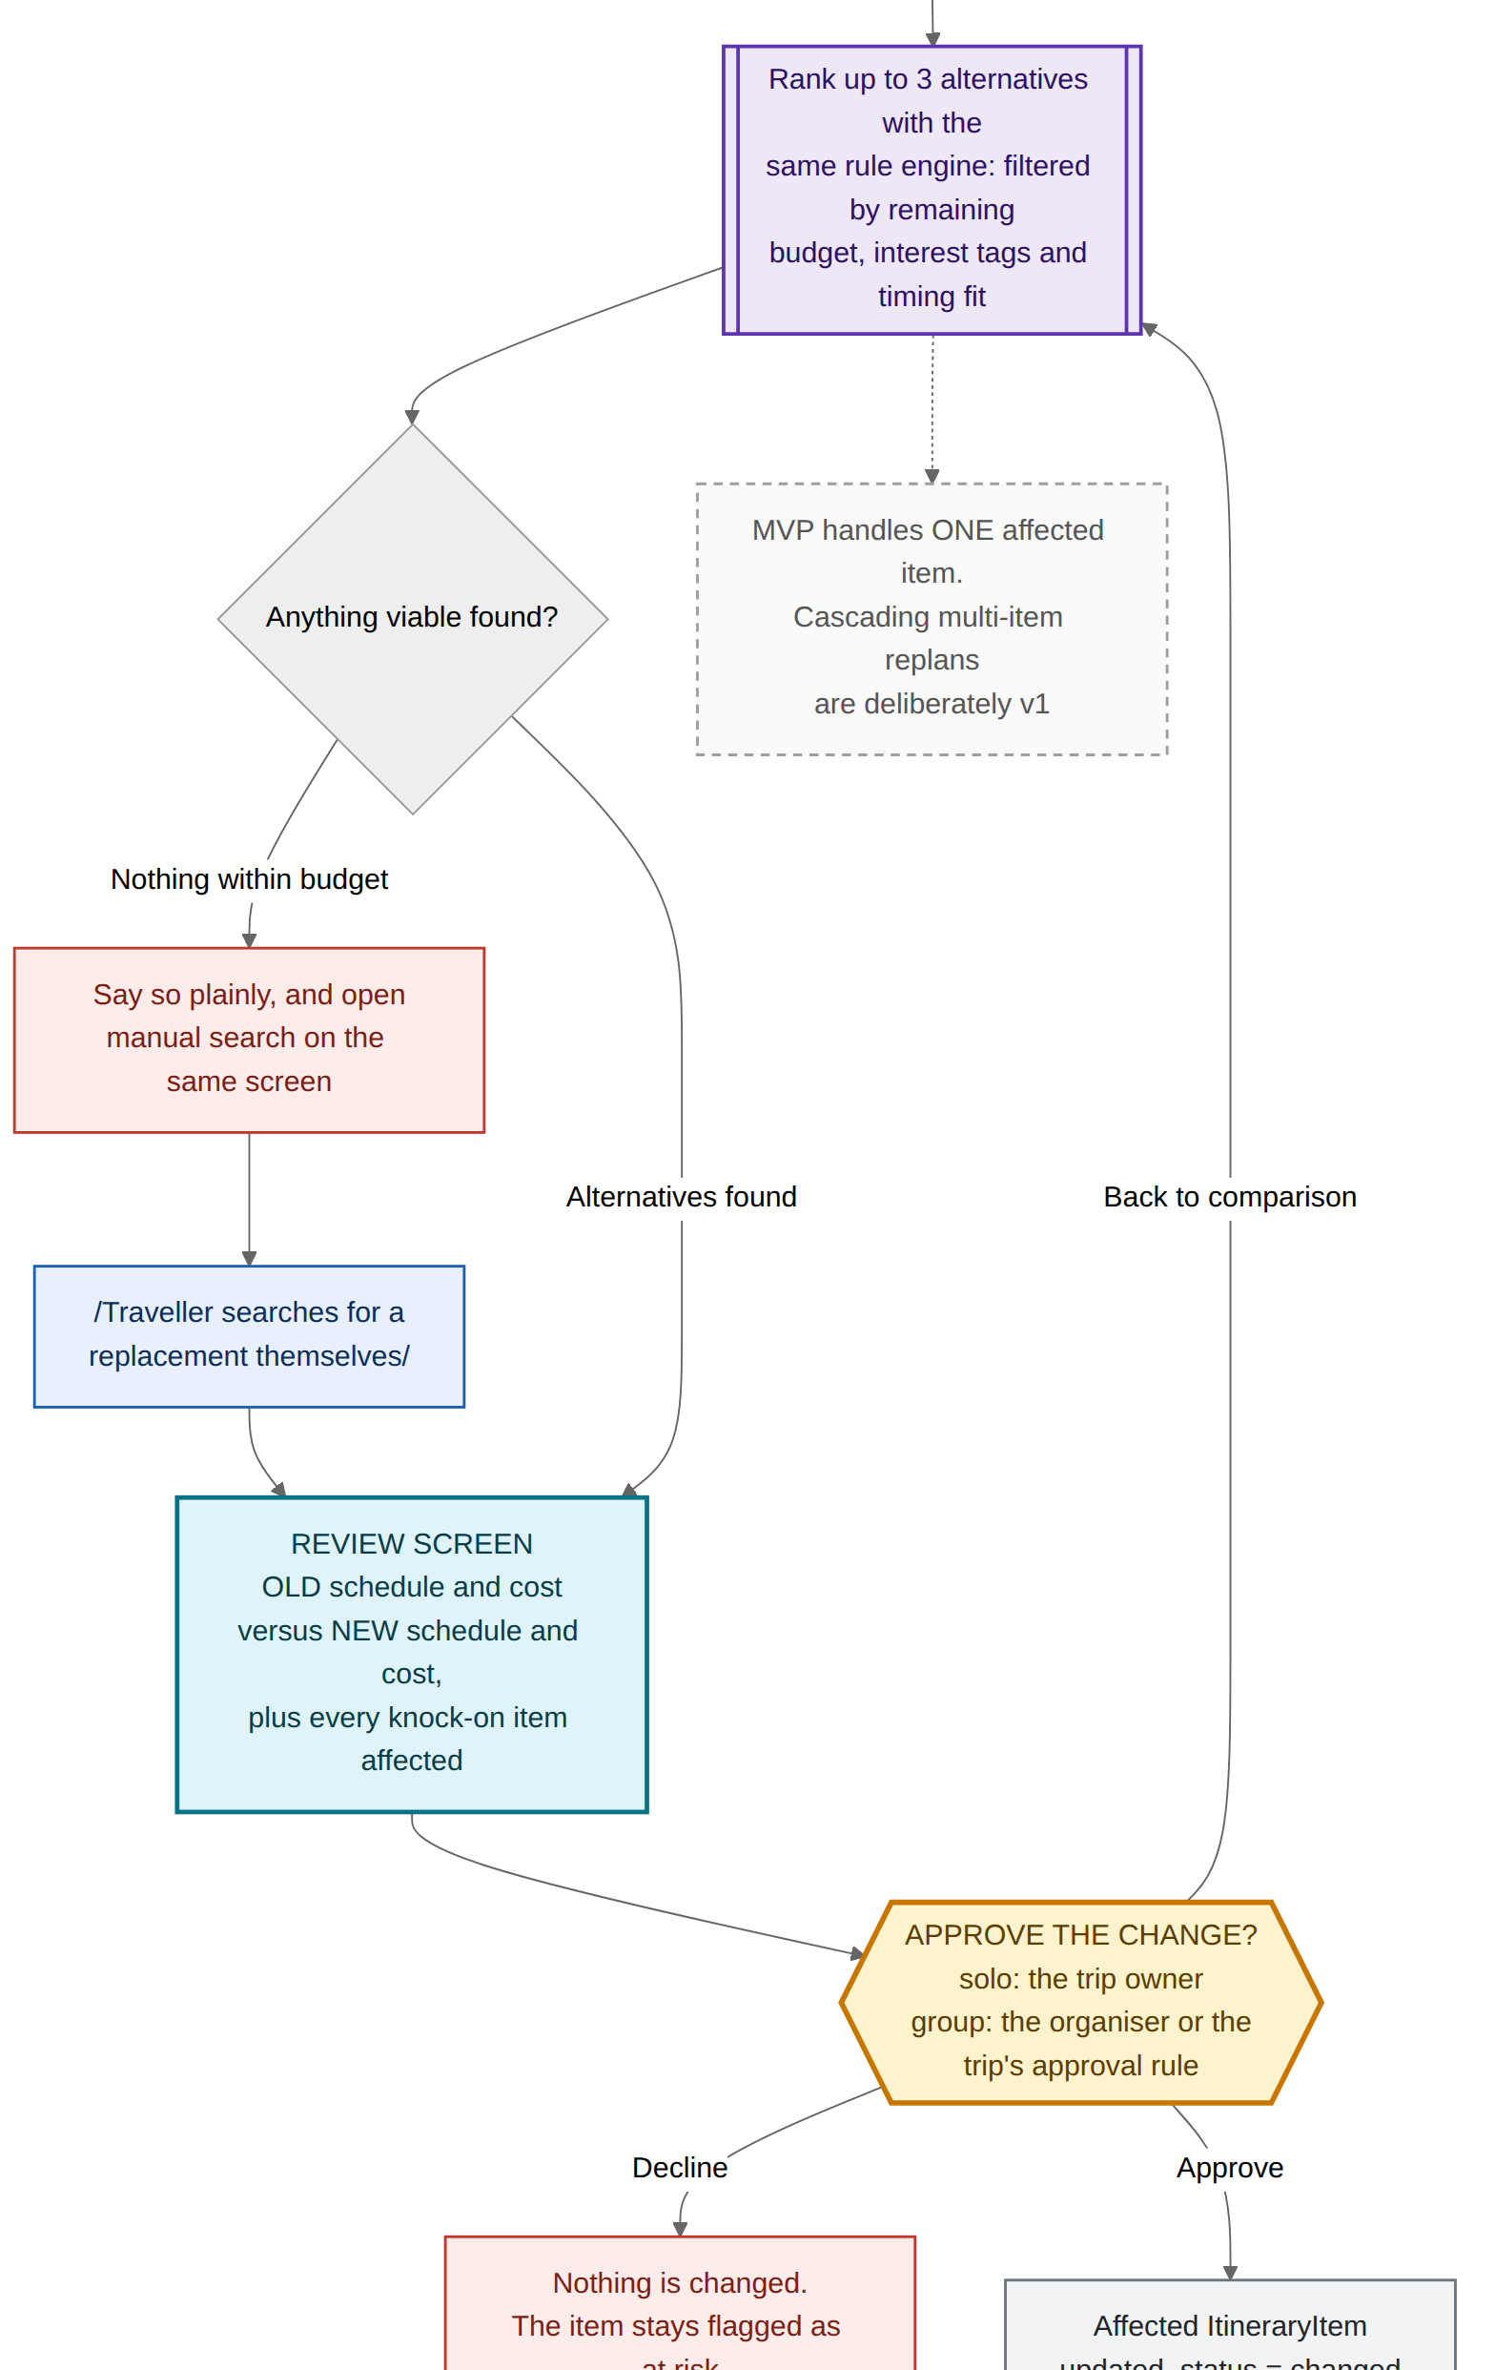
FL-06 — Disruption detection, ranked alternatives, approved replan — part 2 of 3
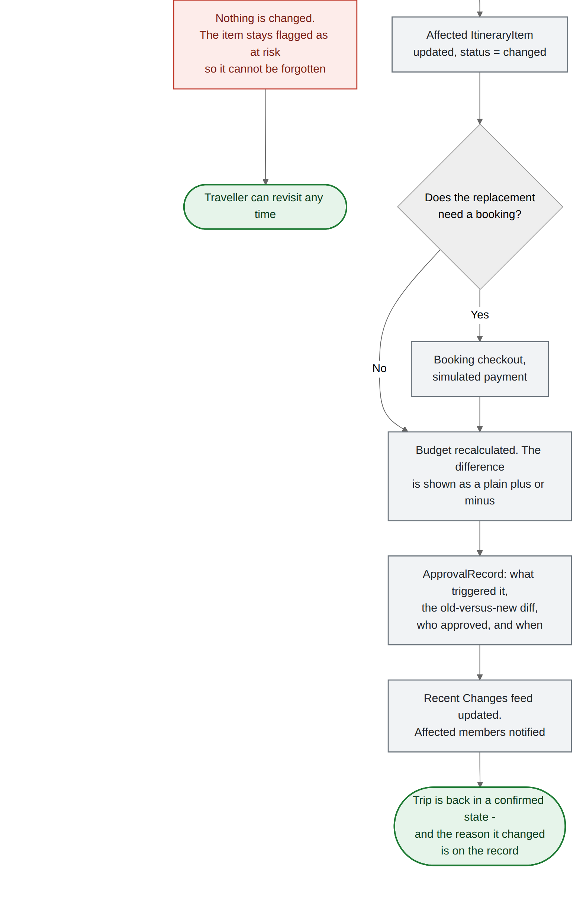
FL-06 — Disruption detection, ranked alternatives, approved replan — part 3 of 3

FL-07 · The approval gate — one component, four entry points
This is the flow to open when a judge asks what makes Aeris different. It is not a screen; it is a shared step that bookings, vote outcomes, accepted recommendations and disruption responses all pass through before anything is written.
Called by | FL-02 booking, FL-04 vote outcome, FL-05 payer, FL-06 replan
Shows | Old versus new schedule and cost, conditions, who is affected
Writes | ApprovalRecord — action, diff, approver, timestamp
Requirements | FR-APPROVE-1 to 4

Branches worth pointing at
- The first decision is what keeps the product usable. Browsing, filtering and draft suggestions are explicitly ungated. Only money, schedule and bookings trigger a review — otherwise "always ask" becomes a click-through habit and the gate stops meaning anything.
- Authorisation degrades to one person on a solo trip. Same component, no ceremony.
- Three exits, not two. Approve, reject, and back to comparison — because the most common real answer to a proposed change is "show me the options again."
- Rejections are recorded too. A declined change appears in Recent Changes as a decision that was made, which is what turns a log into an account of the trip.
- Approved changes apply atomically. Itinerary, budget and bookings move together or not at all — there is no half-updated trip.

What it earns in the rubric
- Originality (7%) and differentiation (3%) — "AI-assisted, human-committed" is a defensible position rather than a feature list.
- Demo-readiness — the PRD success metric asks for the approval trail to be visibly demonstrated twice. This chart is the thing to point at while doing it.
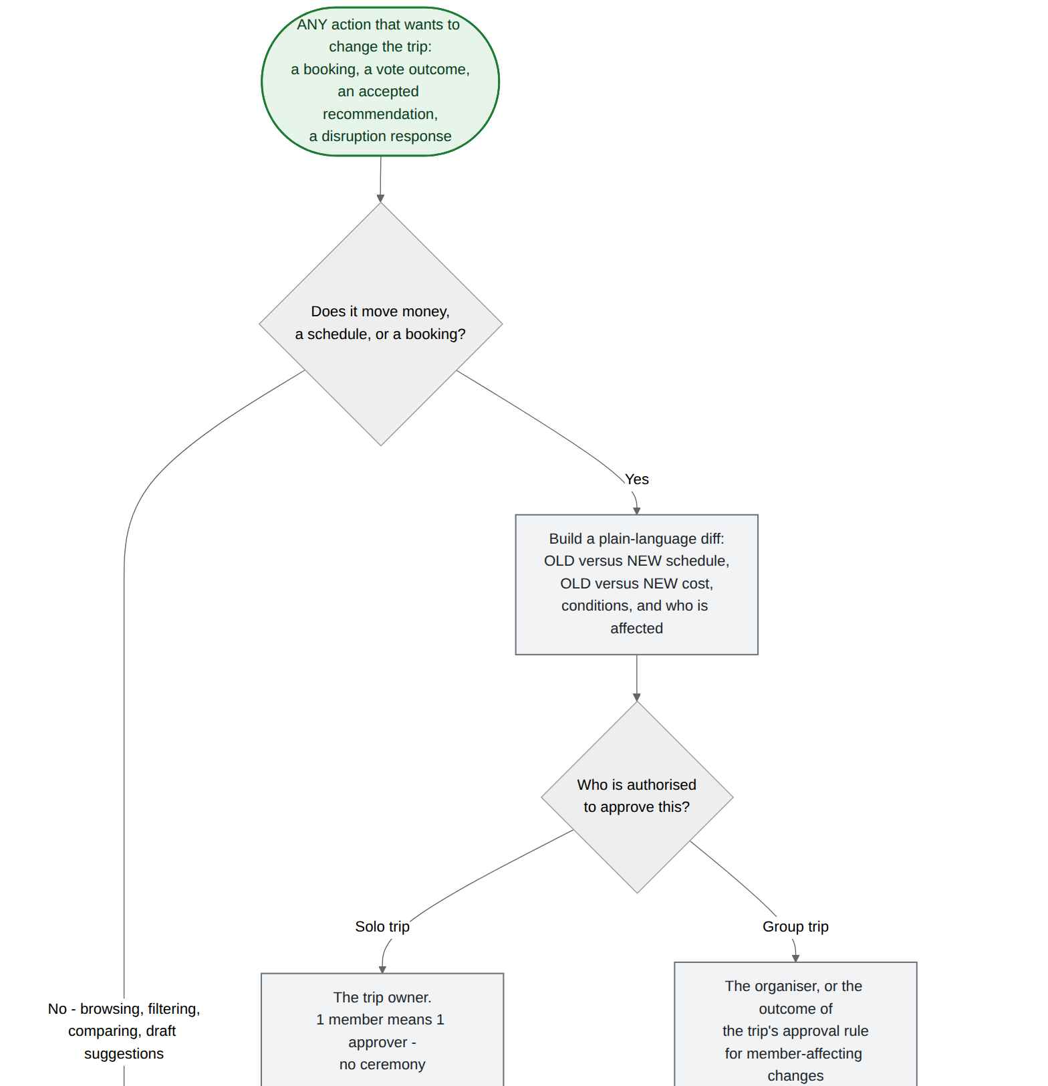
FL-07 — The approval gate — one component, four entry points — part 1 of 2
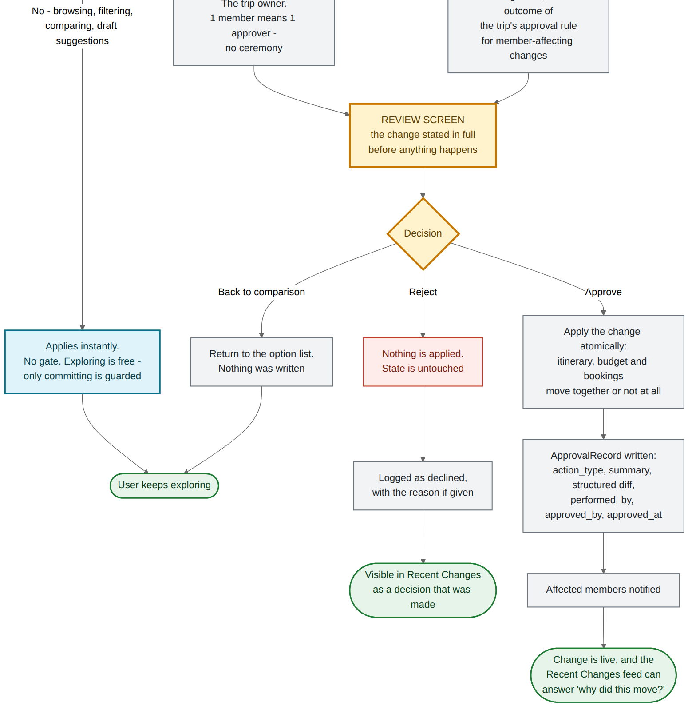
FL-07 — The approval gate — one component, four entry points — part 2 of 2

FL-08 · Screen map — what actually has to be built
The flows turned into a build checklist. Nineteen screens, grouped into three zones, with the approval gate drawn once as a shared component that three different review screens hand off to.
Zones | Account, Trips, The Trip
Screens | 19, of which 4 are group-only
Shared components | 1 — the approval gate
Use it as | The Figma page list and the build ticket list

Branches worth pointing at
- Build the dashboard first. Every flow returns to it, so it is the screen that makes the demo hang together — and it is also the screen a judge looks at longest.
- Build the approval gate second, once, as a component that takes a diff and a callback. Four features get it for free and the demo’s strongest moment gets repeated twice without extra work.
- The four group-only screens can be hidden behind a single member-count check, which is how Rule 03 becomes real in code rather than in copy.

What it earns in the rubric
- Mockup completeness (2%) — a named screen inventory means the mockup set can be checked off rather than eyeballed.
- Visual consistency (4%) — one shared review component is the cheapest way to keep the highest-stakes screens identical.
- Resource and time awareness (4%) — 19 screens is a number you can defend against a hackathon clock.
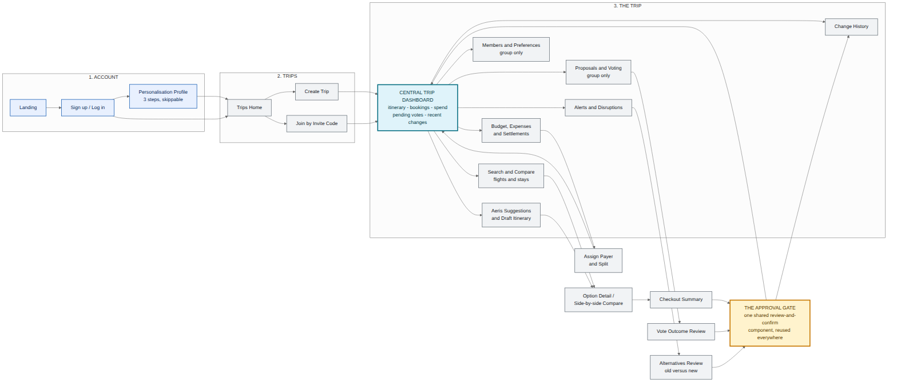
FL-08 — Screen map — what actually has to be built

Decisions we locked while drawing these
The PRD ends with thirteen open questions. A flow chart cannot be drawn around an open question, so each one below was closed with a stated default. Keep this table — the rubric awards 7% for documented iteration, and this is the cleanest evidence of it available.
Open question | Locked default | Why this one
Group approval rule | Simple majority of members who submitted preferences. Organiser breaks ties. | Unanimity deadlocks at four people; organiser-only recreates the single point of failure the product exists to remove.
Deadline with zero votes | Auto-extend once by 24 hours, then the organiser decides. | A silent stall is the failure mode of every group poll. One nudge, then someone is accountable.
Password reset | Emailed single-use token, 30-minute expiry, all sessions invalidated on change. | Standard, cheap, and demonstrable without a security conversation on stage.
Simulated booking cancellation | Allowed. Reverses the budget line, sets the item to cancelled, writes a history entry. | The demo needs a reset button, and reversal exercises the change history a second time.
Currency service outage | Last cached rate plus a visible staleness stamp. Entry is never blocked. | Blocking an expense entry over a rate lookup is worse than a slightly stale number that says it is stale.
Rounding on splits | 2 decimal places, remainder assigned to the payer. | The payer is already out of pocket; giving them the extra cent is the least contentious rule.
Disruption debounce | 15 minutes of sustained disruption before an alert fires. | Short enough to be useful, long enough to skip delays that resolve themselves.
No real-time data available | "Status unavailable" — never a default "on time". | A false reassurance is worse than no information, and it is one line of code either way.
Change history depth | Human-readable summary plus a structured diff. No full-state rollback. | The demo needs the story of what changed, not the ability to time-travel. Rollback is v1.
Searchable categories | Flights and accommodation only. Everything else is a manually added itinerary item. | Two live providers is a build you can finish; five is a build you can describe.
Calendar sync | One-way .ics export of the confirmed itinerary. Two-way OAuth is v1. | Delivers the visible benefit without spending hackathon hours on an OAuth consent flow.
Platform | Responsive web app, designed at 400px and up. | One codebase, demos from any laptop in the room, and the flows assume nothing native.
Team, timeframe, stack | Still open — the one question these flows cannot answer for you. | If the answer is tight, cut FL-05 to equal splits only and FL-06 to flights only. Both degrade cleanly.

Where these flows earn marks
Mapped against the prototype judging rubric. The flow set does not touch every criterion — presentation and mentor feedback are yours to bring — but it is the single artefact that touches the most.
Criterion | Weight | What in this set earns it
Visual diagram and mindmaps | 8% | Nine diagrams across four layers — a master map, six scenario flows, a reusable component flow, and a screen map. That layering is what the top band means by "rich, multi-layered mapping".
Iteration and idea evolution | 7% | The Decisions Locked table: thirteen open questions, twelve closed with stated reasoning, one left open with a named contingency.
Effectiveness of the solution | 7% | Each flow makes the before and after concrete: chat-thread polling becomes a submission counter, hand-run expense maths becomes a settlement plan.
Originality | 7% | The dual-track fork in FL-02 and the approval gate in FL-07 — an AI layer that is optional and reversible rather than authoritative.
Technical viability | 6% | Provider calls, fallbacks, debounce windows and the settlement algorithm are all placed on the charts rather than assumed.
Understanding the problem | 5% | Outages, no-overlap, ties, zero votes, late joiners, no-alternative and unknown status are all drawn as branches.
Target group alignment | 5% | FL-02 is Aina’s flow end to end; FL-03 and FL-04 are Wei Jian’s. Both personas are traceable through specific nodes.
Planning and scope realism | 5% | v1 features appear as dashed nodes inside the MVP charts — the cuts are visible and deliberate, not missing.
Novel features or twists | 5% | Hidden-until-close private voting, and the private consolation alternative for the member who lost the vote.
Usability and UX | 4% | Every error branch terminates in a working screen with a labelled route back.
Visual consistency | 4% | One shape language across nine charts, and one shared review component behind every high-stakes screen.
Resource and time awareness | 4% | 19 named screens and an explicit cut-these-first contingency in the last table row.
Structure and flow (pitch) | 4% | The demo script walks FL-00 from left to right, so the talk track and the architecture are the same shape.
Differentiation | 3% | One sentence: every other planner asks you to trust it, Aeris asks you to approve it.
Reach and scalability | 3% | The watcher and the gate are generic patterns; new categories extend them without redrawing a flow.
Mockup completeness | 2% | FL-00 covers the core flow end to end; FL-08 names every screen that flow touches.

Two minutes, following FL-00 left to right
The PRD’s demo-readiness metric asks for one uninterrupted run that touches all four ideas, with the approval trail shown twice. This is that run, timed.
Time | What you do | Flow
0:00 | The problem, in one line. Five tabs, a spreadsheet and a group chat — and none of them owns the trip. | no slides yet
0:12 | Log in with a profile already filled. Skip the form; show the three values Aeris will actually use. | FL-01
0:22 | Search a real flight. Compare three side by side. Then point at the suggestion feed and ignore it on purpose — that is the argument. | FL-02
0:42 | Confirm Booking — approval gate, first showing. Read the diff aloud. Show the history entry appear. | FL-07, gate 1 of 2
0:58 | Switch to the group trip. "3 of 4 submitted", then the fourth lands and the overlap window appears without anyone polling anyone. | FL-03
1:14 | Cast a private vote. Show that the tally is hidden — including from the organiser — then close the proposal and reveal it. | FL-04
1:30 | Assign a payer, split an expense in a second currency. Land on the settlement suggestion. | FL-05
1:44 | Trigger the disruption. Ranked alternatives, old versus new, approve — approval gate, second showing. | FL-06 + FL-07
1:58 | Close on the change history. Both approvals, both timestamped, both attributable. "Nothing on this trip moved without someone saying yes." | FL-00 end state
One thing to rehearse: the gate is the moment, and it happens twice. Slow down for it both times. Everything else in the demo can be clicked through at speed.

